Please note

Please remove the text that is a color strip
before submitting the draft of the curriculum to the Academic Affair



Master of/ Doctor of …. Degree ….
In ……….
(International Program)
New Curriculum/ Revised Curriculum B.E. ….. (year approved by Board of Trustee)

Faculty……
Payap University

Table of Contents

 |  | Page
Section 1 | General Information
Section 2 | Specific Information of the Program
Section 3 | Educational Management System, Implementation and Program Structure
Section 4 | Learning Management Process
Section 5 | Student Evaluation Criteria
Section 6 | Readiness and Potential for Curriculum Management, Including Faculty Members and Thesis Advisor
Section 7 | Program Quality Assurance
Section 8 | Program Evaluation and Improvement
Details of the revision of the curriculum ((Comparison table of the original curriculum and the revised curriculum)
Appendices
Appendix A | Table showing Program Learning Outcomes (PLOs) with Knowledge/Skill/Ethic/Character
Appendix B | Payap University Announcement Criteria for Credit Transfer of Academic Results, Knowledge, Skills, and Experience, B.E. 2568 (2025)
Appendix C | Course Description
Appendix D | Payap University regulations about practice in the examination and postponement of the graduate studies B.E. 2550
Appendix E | Payap University regulations about Exam Cheating and Plagiarism Graduate Studies B.E. 2550 and Amendments
Appendix F | Database list, the list of books, journals, newspapers and audiovisual materials in the university library
Appendix G | Order of Payap University No...../..... Subject: Appointment of the Curriculum Development Committee .................... Department……
Appendix H | Minutes of the Curriculum Development Committee Meeting .................... Department…….
Appendix I | Copies of working contracts of non-Thai instructors who are responsible for the program
Appendix J | English Language proficiency for international graduate programs at Payap University B.E.2564

Program Specifications
Degree of curriculum
Specify the name of the program, such as the Master of Arts program, the Master of Business Administration program.
discipline
Specify the name of the major, such as Management, Thai Language for Communication.
(International Program)
New Curriculum/ Revised Curriculum B.E. …..

Institution: Payap University
Department/ College/ Faculty
Specify the name of the Department, college/faculty in charge of the course.

Section 1. General information
1. Code and Title of Program
Program Code xxxxxxxxxxxxxx

- Refer to the course code from the CHECO system.
- In the case of a new course, leave it blank to fill in the course code after the course is approved/ acknowledged from the MHESI and has received the course code from the MHESI.

Program Title (Thai) :
Program Title (English) :
Provide the full name of the curriculum and program in both Thai and English, such as:
ภาษาไทย : หลักสูตรศิลปศาสตรบัณฑิต สาขาวิชาภาษาศาสตร์
ภาษาอังกฤษ : Master of Arts Program in Linguistic

2. Degree Title and Field of Study
Title of Degree (Thai) : (Full name of Thai language degree in Thai language)
Abbreviated Title (Thai) : (Abbreviation of Thai Language Degree in Thai Language)
Title of Degree (English) : (Full name of English Degree)
Abbreviated (English) : (Abbreviation of English Degree)
The full name and initials of the degree in both Thai and English must be consistent with each other and in accordance with the criteria for determining the name of the degree of the MHESI.

3. Major Field (If applicable)
None
Yes, Please specify

4. Total Credit Hours
The total number of credits throughout the course is not less than ..... credits.

The number of credits taken throughout the course must meet the 2022 Graduate Program Standards.

5. Type of Program
5.1 Degree Level
Master’s Degree
Doctoral Degree
Others: (please specify)

5.2 Language
Thai Language
International Language (specify)
Bilingual Program (Please specify the language used)

5.3 Admission
Thai students only
Non-Thai students only
Both Thai and Non-Thai students

5.4 Collaboration with Other Institutions
No collaborations with other institutions
This program is in cooperation with external organization
Name of institution Country
Type(s) of cooperation …….
Collaborate and awarding degrees by Payap University.
Collaborate by awarding degrees from both Payap University and external organizations.

In the case where a curriculum collaborates with other educational institutions or organizations, please specify the name of the collaborating organization and describe the nature of the collaboration. According to the **Curriculum Standards of 2022**, the term **“external organization”** is defined as follows:

An external organization refers to **higher education institutions, either domestic or international, that are accredited by the relevant education authority of that country**, or **government agencies at the department level or equivalent, state enterprises, public organizations, or private companies listed on the Stock Exchange of Thailand**.

5.5 Awarding degrees to graduates
Specific courses of Payap University
One Degree
Dual Degree (Two degrees from two programs)
- The faculty with primary responsibility.......................................................
- Joint Responsible Faculty........................................................
Joint Degree (A single degree is awarded, but it is a joint program between faculties.)
- The faculty with primary responsibility.......................................................
- The co-responsible faculty........................................................

Joint Program with External Organization (Specify in case the program has an MOU with an external organization.)
- Dual Degree
(Awarded two degrees from Payap University and an external organization.)
Awarded Degree from........................... (specify external organization)
Degree Name (Full name): ............. Program in (if any).........................................
Thai Abbreviation (If any): ……………… (…………………………………………)
English Abbreviation : ……………… (…………………………………………)
(In case of more than one institution - please provide all the name of the external organization and the name of the degree.)

- Joint Degree
(A single degree is awarded, but it is a joint program between Payap University and External Organization)
External Organization ………………………. Country ………………………………

6. Program Status and Endorsement/Approval
6.1 Program Status
New curriculum B.E.....
Open in a two-semester system 1st semester
2nd semester
Revised curriculum B.E.....
Open in a two-semester system 1st semester
2nd semester

The curriculum was revised from ………(Degree)...... Program in.......................(Original curriculum)
The curriculum was firstly approved in B.E. .... (The year in which the curriculum began to be used shall be indicated.)
Last revision in B.E. …..(Specify the year. B.E. as stated on the cover of the previous edition of the curriculum.)..

  - Endorsement/Approval (Only according to the following list of committees.)
Considered by the Program Development Committee, ..(Degree)…. Program in Date Month B.E.
Considered by the Graduate Studies Committee in the /
Date Month B.E.
Considered by the Academic Committee of the Board of Trustees in the
/ Date Month B.E.
Approved by the Board of Trustees, Payap University in the
ครั้งที่ / Date Month B.E.
Accreditation of curriculum by professional organizations (If any)..............
(Identify the organization that provides the certification) Date Month B.E.
(Note: In the case of curriculum directed by professional organizations, the order of the committee shall be determined by the professional organization.)

7. Name ID No/Passport No. Academic Rank, and Degree of Faculty Members Responsible for the Program
Specify your name-surname, ID number. Academic Position Qualifications (All Levels of Education) Field of Study The name of the educational institution and the year of graduation of the lecturer in charge of the course with a minimum of
3 people. For the identification of academic works in the last column, it is according to the reference in the APA 7th edition system, which can be studied and see examples of citation writing from
https://so02.tci-thaijo.org/index.php/EDUCU/article/view/153329/111738

No. | Name – Family Name | ID No. /Passport ID | Academic Rank | Degree | Major | Institution | Year of Graduation | Academic Work in the past 5 years

(If you graduated from a foreign educational institution. Please include the name of the city and the country where the educational institution is located.)
Sorting according to the highest academic position Educational qualifications and the year in which they graduated according to the highest qualifications, such as:
1. Prof.
2. Assoc. Prof
3. Asst. Prof. Dr.
4. Asst. Prof.
5. Lecturer
In the case of the same educational level, the first person to graduate shall be ranked first.
6. Lecturer A (Academic Year of Doctoral Degree 2015)
7 Lecturer B (Academic Year of Doctoral Degress 2017)
8. Lecturer C ( Master's Degree Year 2015)
9. Lecturer D ( Master's Degree Year 2017)

8. Instructional Venue
Payap University, Amphoe Muang, Chiang Mai

9. Rationale and Background for the Curriculum (Demonstrates the curriculum's responsiveness to societal needs, modernity, and uniqueness.)
9.1 Response to National Policies and Strategies (What are the issues? how)
National Strategy 6 kind
Summary of the Master Plan under the National Strategy
…………………………………………………………………………………………………………………………………………………
9.2 Responding to the Sustainable Development Goals of SDGs (What are the issues? how)
SDGs https://www.un.org/development/desa/disabilities/envision2030.html
…………………………………………………………………………………………………………………………………………………
9.3 Responding to the Policy, Vision, Mission, and Identity of Payap University (how)
…………………………………………………………………………………………………………………………………………………
9.4 Responding to Stakeholder Needs (Identify how the curriculum responds to the key stakeholders of the curriculum. It must demonstrate the consistency of the curriculum design and the results of the needs analysis of key stakeholder groups such as Payap University. entrepreneur alumnus Current students, graduate users, etc. )
…………………………………………………………………………………………………………………………………………………

Section 2 Specific Information of the Program

1. Philosophy, Significance, and Program Learning Outcomes

Specify the philosophy, objectives, and learning outcomes of the curriculum in alignment with the university’s educational philosophy:

"Education based on truth and service, fostering individuals of integrity and excellence, with moral values to contribute to and serve society."

The statement should be concise and reflect the belief in teaching and learning, rather than simply describing the desired graduate attributes.

Philosophy

Program Objectives for producing graduates who will:

(This should align with the **Graduate Program Standards of 2022**, which state that:

*"The objectives of a master's degree program should focus on equipping graduates with knowledge and understanding of the process of creating and applying new knowledge for the development of work and society. Meanwhile, a doctoral degree program should aim to develop students' ability to conduct research to generate new knowledge or innovations that contribute to the advancement of work, society, the nation, and the global community."*)

***check the Graduate program standards of 2022 for Doctoral Degree

  - Program Learning Outcomes: PLOs
1.
2.
3.

The **learning outcomes** of graduates at all levels must align with the **university’s educational philosophy**:

*"Education based on truth and service, fostering individuals of integrity and excellence, with moral values to contribute to and serve society."*

Additionally, they should reflect the **university’s vision** and comprehensively cover at least the following four areas:

1. **Knowledge**
2. **Skills**
3. **Ethics and morality**
4. **Personal attributes**

The curriculum should define **Program Learning Outcomes (PLOs)** in accordance with the **Higher Education Qualification Standards Learning Outcomes Announcement (2022)**. https://www.ops.go.th/th/ches-downloads/edu-standard/item/6940-2022-07-22-02-54-49

** Ensure that the **sequence of objectives and Program Learning Outcomes (PLOs) is aligned**.

For example:

- **Objective 1**: To produce graduates with comprehensive knowledge in the discipline...
- **PLO 1**: Demonstrate the ability to apply knowledge in the discipline to develop...

Each **PLO should correspond logically to the related program objective**, ensuring a clear connection between what the curriculum aims to achieve and the measurable learning outcomes expected from graduates.

2. Plan for Development and Improvement
Development/Improvement Plan | Strategies | Evidence/Key Performance Index
- Curriculum Standards and Graduate Production |  | The evidence should be concrete, such as showing the results in quantity, number, statistics, and work at the threshold level. Evaluation, Learner Satisfaction Assessment Report, Graduate User Evaluation Report, Number of Research, Academic Articles, etc.
- Research
- Academic Service
- Art and Culture
- …

Note: Development topics other than Items 1 and 2 can be adapted to suit the context of the curriculum.

Section 3 Educational Management System, Implementation, and Program Structure

1. Educational Management System
1.1 System
Payap University uses a bi-semester educational system for each academic year. An academic year consists of two semesters: 1st semester and 2nd semester. Each semester lasts no less than 15 weeks.

1.2 Summer Session
The offering of a summer session is optional. Each summer session is no less than 5 weeks while maintaining the same credit hours operated in a regular semester
Nos. of Summer session (ex. 1, 2, 3, etc) will be offered.
Summer Sessions are not available (In the case where it is necessary to offer a summer session, it shall be at the discretion of Payap University.)

1.3 Comparable Credits in the Bi-Semester System:
Uses a **bi-semester system** in accordance with the regulations of the **Ministry of Higher Education, Science, Research, and Innovation**.

2. Program Implementation
2.1 Teaching Schedule
2.1.1 Academic Calendar

Semester | Duration | Weeks
Semester 1 | August–December | 15
Semester 2 | January–May | 15
Summer (If a curriculum does not provide for summer education, it is cut off.) | June – July | 5

2.1.2 Day-Time
Weekdays – official working days
Weekend – nonregular working days (Please specify)

2.2 Student Qualifications
2.2.1 Qualifications of Prospective Students
A. General requirements
Graduated with a **degree in …………** from domestic or international educational institutions accredited by the agency authorized to provide accreditation in that country.
An applicant must pass the English (or other languages) criteria set by the university, faculty, or a curriculum
An applicant must have good behavior.
ข. Specific qualifications (Please specify)
Additional qualification criteria (please specify) example
Have a cumulative average score of not less than ....
Have no less work experience. ... year

2.2.2 Admissions
The admission is based on the criteria of Payap University
Other (please specify)

2.3 A Five-Year Plan for Student Enrollment and Graduation
--Specify the number of students completely, both regular and special sessions (if any).
If the course has multiple plans/plans, separate tables showing each plan/plan.

Year of Study | Number of students expected in each year
Year of Study | 256../202.. | 256../202.. | 256../202.. | 256../202.. | 256../202..
Year 1
Year 2
Total
Number of Prospective Graduates

2.4 Budget Plan
(The curriculum should coordinate with the Office of Financial Management to request information in the budget section.)
2.4.1 Income (Baht)
Income | Budget Year
Income | 256../202.. | 256../202.. | 256../202.. | 256../202.. | 256../202..
Course Fees
Tuition Fees
Administration Fees
Additional fees
Total

2.4.2 Expenses (Bath)
Catagories | Budget Year
Catagories | 256../202.. | 256../202.. | 256../202.. | 256../202.. | 256../202..
A. Operating
- Salary
- Administrative Position Payment
3. special compensation
4. Administration Costs
5. Health Care
6. Academic Budget
7. Student Activities Budget
8. Scholarship
Total (A)
B. Investment budget
1. Office Tools and Maintenance
2. Other Asset
Total (B)
Total (A) + (B)
Students*
Cost per student
* Remark The total number of students, including those in the previous and revised curricula.

2.5 Teaching and Learning Mode
Classroom Mode

2.6 Credit Transfer and Course Transfer
The transfer of course credits must be in accordance with the 2022 graduate level academic transfer criteria.

3. Curriculum and Instructors
3.1 Curriculum
3.1.1 Number of Credit Hours
A total of credits
3.1.2 Curriculum Structure (This shall comply with the Graduate Program Standards of 2022 and align with the curriculum's own academic plan.)
Master’s degree
The curriculum structure is divided into: ... The plan is as follows: Academic Plan 1 and Professional Plan 2 (specified according to their own curriculum):
Plan 1 Academic (minimum 36 credits)
Thesis ......... credits (At least 12 credits)
…….

Plan 2 Professional (minimum 36 credits)
Independent Study ......... credits (At least 3 credits not more than 6 credits)
…..

Doctoral Degree
The curriculum structure is divided into: ... The plan is as follows: Plan 1 and Plan 2 (specified according to their own curriculum):
Plan 1
(A research-focused study plan that includes a thesis contributing to new knowledge. Higher education institutions may require additional coursework or academic activities beyond the credit requirements. However, these must meet the expected learning outcomes as defined by the institution.)
Plan 1.1 Students who have a master’s degree Thesis: ........ credits (at least 48 credits)
Other (if any ........................................ (please specify)
Plan 1.2 Students who have a bachelor’s degree
Thesis: ........ credits (at least 72 credits)
Other (if any ........................................ (please specify)

Plan 2
(It is a research-oriented study plan by producing a high-quality thesis that contributes to academic and professional advancement and additional coursework.)
plan 2.1 Students who have a master’s degree
Thesis: ........ credits (at least 36 credits)
Course work ……… credits (at least 12 credits)
Other (if any ........................................ (please specify)
plan 2.2 Students who have a bachelor’s degree
Thesis: ........ credits (at least 48 credits)
Course work ……… credits (at least 24 credits)
Other (if any ........................................ (please specify)

Master’s Degree (The structure or composition of the curriculum shall be displayed by dividing the subjects into categories in accordance with the study plan of the course and the number of credits shall meet the curriculum standards. B.E. 2565 (2022)

Course Structure | Plan 1  (credits) | Plan 2  (credits)
Prerequisite courses
Core courses
Elective courses
Thesis/Independent study
Total

Doctoral Degree
Course Structure | Plan 1  (credits) | Plan 2  (credits)
Prerequisite courses
Core courses
Elective courses
Thesis/Independent study
Total

3.1.3 Course Titles (The accuracy of the course code and other details related to the Registry Office shall be verified before submitting the course details to the Academic Affair for presentation to the Academic Committee of the Council.)
3.1.3.1 Meaning of course codes
Course codes consist of abbreviated letters and coded digit numbers
which carry meanings as follows
1) Abbreviated Letters
..... Meaning ....
(specify both Thai and English)
2) Numbers are made up of 3 digits numbers as follows:
2.1) Hundreds
Number … means ……………
2.2) The numbers in the tens
Number … means ……………
2.3) The numbers in the digits place
Number … means ……………

The series of numbers in parentheses after the number and name of the course
indicate the number of hours in the course (number of lecture hours - number of lab/practice
hours - number of self-study hours, e.g. 3-0-6).

3.1.3.2 Prerequisite courses
Prerequisite Course refers to a course that a student must pass before enrolling in the more advanced course. When a course has a prerequisite, it means that a student must have certain knowledge to be successful in the course. An assessment exam with qualifying scores of a prerequisite is achieved by a final grade of A, B+, B, C+, C, P, CE, or CS

Courses in the curriculum
1. Prerequisite courses
(Specify courses and credits without describing the course, such as:
500 English for Musicians 0 (3-0-6) credits)
2. Core courses

3. Elective courses

4. Thesis

5. Independent Study

3.1.4 Study Plan (s) (The study plan shall be presented separately according to the curriculum structure plan presented in 3.1.2 and the study plan shall be presented for all semesters according to the duration of the course, such as a three-year course. In every academic plan, it must be provided for 6 semesters.)
Identify the subject code. Name of course and number of credits (lecture hours-practice-self-study)
Self-study hours calculation Calculated from ((lecture hours * 2)+(practice hours * 0.5))
**Undergraduate and graduate levels are calculated using the same formula**

Year | Semester 1 |  |  | Semester 2
1 | XX XXX | Course Subjects | X(X-X-X) | XX XXX | Course Subjects | X(X-X-X)
 | XX XXX | Course Subjects | X(X-X-X) | XX XXX | Course Subjects | X(X-X-X)
 | XX XXX | Course Subjects | X(X-X-X) | XX XXX | Course Subjects | X(X-X-X)
 | XX XXX | Course Subjects | X(X-X-X) | XX XXX | Course Subjects | X(X-X-X)
 |  | Total |  |  | Total
Summer | XX XXX | Course Subjects | X(X-X-X)
 | XX XXX | Course Subjects | X(X-X-X)
 |  | Total
If there is no summer term, cut it off.
Year | Semester 1 |  |  | Semester 2
2 | XX XXX | Course Subjects | X(X-X-X) | XX XXX | Course Subjects | X(X-X-X)
 | XX XXX | Course Subjects | X(X-X-X) | XX XXX | Course Subjects | X(X-X-X)
 | XX XXX | Course Subjects | X(X-X-X) | XX XXX | Course Subjects | X(X-X-X)
 | XX XXX | Course Subjects | X(X-X-X) | XX XXX | Course Subjects | X(X-X-X)
 |  | Total |  |  | Total
Summer | XX XXX | Course Subjects | X(X-X-X)
 | XX XXX | Course Subjects | X(X-X-X)
 |  | Total
3.1.5 Course Descriptions
Please see Appendix C

3.2 Curriculum Core Faculty Members
(The qualifications and academic works must meet the 2022 Graduate Program Standards. The identification of academic works must be in accordance with the references in the APA 7th edition system, which can be studied and see examples of writing references from
https://so02.tci-thaijo.org/index.php/EDUCU/article/view/153329/111738

- List at least 5 full-time lecturers. (The * sign at the end of the name of the lecturer in charge of the course shall match the list from Section 1, no 7). The order shall be as prescribed in Section 1, no 7.

No. | Name – Family Name | ID No. /Passport ID | Academic Rank | Degree | Major | Institution | Year of Graduation | Teaching  loads in  the  program | Academic Work in the past 5 years
 |  |  |  |  |  |  |  |  | APA7th

Note * Refer to Faculty Members Responsible for the Program
4. Field Experience Courses (if any)

Identify the code and name of the course that has the teaching and learning model from the field experience, such as practical training or cooperative education defined in the curriculum, and briefly summarize the teaching and learning style of the course.
4.1 Learning outcomes of field experience

- Identify key learning outcomes from the desired field experience, which must be consistent with Curriculum Mapping showing the alignment of the course CLOs and PLOs (as presented in the course details), as well as professional practice skills (if any).

4.2 Time frame

Specify the duration of the course that provides students with field experience, such as the semester of ....

4.3 Scheduling

For example, 3 days a week for 4 weeks, or full-time in the ...... year, semester .....

4.4 Assessment

Explain the process of evaluating learning outcomes from field experience.

5. Requirements for Projects or Research (If any)
5.1 Thesis
5.1.1 Briefly Description

Specify the description of the thesis course.

5.1.2 Learning Outcomes from Thesis Courses

- Identify the main learning outcome standards from the thesis course, which must match those specified in the Curriculum Mapping that shows the consistency of the CLOs of the course and PLOs (as presented in the course details), as well as professional practice skills (if any).
5.1.3 Time frame
(It can be added according to the context of curriculum management, but it must not be contrary to the 2022 Curriculum Standards.)
5.1.3.1 Students can propose topics and thesis proposal only if:
Have studied at least ... credits
Pass all compulsory courses according to the curriculum.
Achieved a cumulative GPA of no less than 3.00.
Passed the **qualifying examination** to be eligible to conduct and present a thesis (for doctoral degree programs).
Other (specify)
5.1.3.2 A student may present their thesis work and undertake the final oral defense only if the following conditions are met:
Successfully completed all required courses in the curriculum, totaling ... credits.
Achieved a cumulative GPA of no less than 3.00.
Received approval from the thesis advisor.
Received approval from the administration of the college/faculty to which the student belongs.
Other (specify)

5.1.4 Number of credits
credits

5.1.5 Preparation
The university prepares the following resources to assist the students:
5.1.5.1 Thesis manual
5.1.5.2 Appoint the thesis main advisor and thesis proposal defense committee to
help the students in preparing their thesis.
5.1.5.3 Provide resources for the students to do the research.
5.1.5.4 Provide software for data management and statistical analysis.
5.1.5.5 Organize extra-curricular activities to support students’ thesis work such as
dissertation promotion seminar, thesis coaching workshop, peer-mentoring program.
If the cirriculum has other preparations, briefly explain the arrangements for providing academic advice and support to students.

5.1.6 Evaluation Process (Select the level of education that corresponds to your curriculum and remove the irrelevant level.)
Master’s Degree
The University has a process for evaluating and verifying the results of the independent study as follows:
5.1.6.1 The student must orally defend the completed independent study in front of the independent study defense committee which comprises of at least 3 members, consisting of Program Faculty members and external expert(s). The chair of the committee must not be the major adviser or co-adviser (if any). They must have a degree, qualifications, and publications according to the Graduate Program Standard Criteria.
5.1.6.2 The University will establish a student’s independent study defense and oral presentation. The final oral defense is open to the public.
5.1.6.3 Grades for the oral defense of the independent study will be: EP, P or NP.
5.1.6.4 The independent study must be published or accepted for publication; at a minimum, the results or a part of the results must be published in any retrievable form.
5.1.6.5 The department will establish a committee to validate the academic standards of the independent study by considering the following points: research methodology and the acknowledgement of previous research. The committee may also interview the student.

Doctoral Degree
The University has a process for evaluating and verifying the results of the thesis as
follows:
      - The student must orally defend the completed Thesis in front of the Thesis defense committee which comprises of at least 5 committee members, consisting of Program Faculty members and external expert(s). The chair of the committee must be an external expert, and all committee members must have a degree, qualifications, and publications according to the Graduate Program Standard Criteria 2565 (2022).
      - The University will establish a student’s thesis defense and oral presentation. The final oral defense is open to the public.
      - Grades for the oral defense of the Thesis will be EP, P or NP.
      - For Plan 1
The thesis or a part of the thesis must be published, disseminated, or at least accepted for publication in at least two high-quality international journals, as specified by the Higher Education Standards Committee Announcement.
Alternatively, the thesis or a part of the thesis must be published, disseminated, or at least accepted for publication in at least one high-quality international journal, as specified by the Higher Education Standards Committee Announcement, and must also result in at least one of the following:
An innovation or creative work that can be utilized for commercial, social, or economic benefits.
A patent or at least one registered intellectual property.
In the case of innovation or creative work, the thesis must be evaluated by at least three external experts in the same or a related field who possess recognized expertise, knowledge, and experience, and must be approved by the university council.

For doctoral students in the fields of social sciences and humanities, publication in a high-quality national journal, as specified by the Higher Education Standards Committee Announcement, may be acceptable.
For Plan 2 The thesis or a part of the thesis must be published, disseminated, or at least accepted for publication in a high-quality international journal, as specified by the Higher Education Standards Committee Announcement, or must be granted a patent.
Alternatively, the work must be an innovation or a creative work that can be utilized for commercial, social, or economic benefits. In the case of innovation or creative work, the thesis must be evaluated by at least three external experts in the same or a related field who possess recognized expertise, knowledge, and experience, and must be approved by the university council.
For doctoral students in the fields of social sciences and humanities, publication in a high-quality national journal, as specified by the Higher Education Standards Committee, may be acceptable.

5.2.4 Total Credits
credits

Section 4 Learning Management Process
4.1 Teaching and Learning Process
PLOs | Learning Process | Teaching and Learning Activities | Assessment and Evaluation Methods
PLO1 …..  Please specify the final competencies that students are expected to achieve. | Project-Based Learning  Experiential Learning  Case-Based Learning  .............................. | Lecture  Practice / Laboratory / Practical Training  Assignment / Independent Study  Project  Other (Please specify) .............................. | Examinations  Reports / Presentations  Assignments / Exercises / Portfolio / Reflective Writing  Group Projects  Class Activities  Discussions  Observation of Student Behavior  Other (Please specify) ..............................

PLO2 …..

PLO3 …..

PLO4….

PLO5…

4.2 Evaluation of Expected Learning Outcomes (ELOs)
The evaluation of the program’s expected learning outcomes (ELOs) will be conducted on a competency-based approach by ……………………………………… The assessment framework is as follows:

Implementation Guidelines
.................
................

Assessment Tools
.....................................
Passing Criteria
.......................................

4.3 The Relationship between the Institutional Vision and Mission, Faculty Vision, and
Program Learning Outcomes (Put )
 | PLO1 | PLO2 | PLO3 | PLO… | PLO…
Education Philosophy
"Education based on truth and service, fostering individuals of integrity and excellence, with moral values to contribute to and serve society."
Vision
“International Learning Resource for Global Citizens”
Mission
1. Producing graduates in accordance with higher education standards and the university’s identity: “Morality guides the heart, serving society, advancing academic excellence, and progressing toward internationalization.”
2. Integration of the university’s educational missions
3. Promotion of “Truth and Service” in line with the university’s philosophy
4. Enhancement of international identity
5. Lifelong learning
Identity
Morality at Heart, Service to Society, Academic Excellence, Global Advancement.
Faculty Vision
(Specify the vision at the faculty level.)
Stakeholders’ Needs (Examples)
Example 1. Employers / Graduate Users
1.1 Ability to perform work in accordance with professional standards
1.2 Ability to communicate effectively
2. Faculty Members
2.1 Ability to apply knowledge and skills for lifelong learning
3. Alumni
3.1 ………………………………………
4. Other Stakeholder Group (please specify
4.1 ………………………………………
Thailand NQF (National Quality Frameworks)/Asean Frameworks/ Global Frameworks (reference for master’s degree or doctoral’s degree)**
**aFormulation of the “expected learning outcomes” shall consider the national,
regional and global points of reference of a postgraduate programme. As such,
elements related to original research, novelty, emerging theories and practice in
solving real-world problems, etc., in the graduate profile should be assessed and
benchmarked. (Example : Thailand NQF)

4.4 The Alignment of Program Learning Outcomes (PLOs) with the Higher Education
Standards for Student Learning Outcomes (B.E. 2565). (Learning level according to the chosen learning taxonomy.)

Program Learning  Outcomes (PLOs) | Generic Skill | Specific Skill | Higher Education Standards for Student Learning  Outcomes 4 areas (B.E. 2565)
Program Learning  Outcomes (PLOs) | Generic Skill | Specific Skill | Knowledge  (Congitive) | Skill  (Psychomotor) | Ethics  (Affective) | Character  (Affective)
PLO 1: |  |  | Apply
PLO 2: |  |  | Create |  | Valuing
PLO 3: |  |  |  | Precision
PLO ...: |  |  |  |  |  | Valuing
PLO ...:

4.5 Year Learning Outcomes : YLOs
Definition:
Yearly Learning Outcomes (YLOs) describe the attributes, knowledge, and abilities that learners are expected to achieve at the end of each academic year. YLOs must align with the program’s objectives and Program Learning Outcomes (PLOs). They also serve as the basis for determining the courses to be taken in each year of study.
Examples:
Year 1: Learners are able to explain fundamental principles of …, and demonstrate basic skills in thinking, speaking, and the use of simple technological media.
Year 2: Learners are able to describe processes and produce …, and demonstrate public communication skills …
Year 3: Learners are able to design innovations in …, communicate effectively, and use technological media to present information to the community, as well as work effectively as part of a team.
Year 4: Learners are able to integrate and apply knowledge of …, demonstrate a positive professional attitude, and perform systematic critical analysis.

Year | Expected Learning  Outcomes at the end of the year | PLOs | Assessment and Evaluation Methods of Learning Outcomes at the End of Academic Year | Target Value | Courses Supporting the YLOs
1 | -Learners can explain the principles of.... | PLO1  (partial)
2
3

4.6 The Curriculum Mapping of Program Learning Outcomes and Course Subjects

ความรับผิดชอบหลัก

Course Subjects | Credits | Program Learning Outcomes (PLOs)
Course Subjects | Credits | PLO1 | PLO2 | PLO3 | PLO.. | PLO..
Thesis/Independent study
Core course subjects
Elective course subjects

Section 5 Student Evaluation Criteria

5.1 Regulations and Criteria for Evaluating Students’ Achievements (Grading)
The evaluation is based upon Payap University’s Graduate Academic Regulations. The grades have the following meanings

Grade | Grade Points | Meaning
A | 4.0 | Excellent
B+ | 3.5 | Very good
B | 3.0 | Good
C+ | 2.5 | Fairly good
C | 2.0 | Fair
D+ | 1.5 | Poor
D | 1.0 | Very poor
F | 0 | Fail

In addition to the letter grades above, other letters may be used with different meanings as follows:

Grade | Meaning
I | Incomplete
W | Withdrawn
U | Audit
P | Pass
NP | No Pass
IP | Grading in Progress
EP | Excellent Pass
CE | Credits from Examination
CS | Credits from Standard Test

5.2 Curriculum Assessment Plan
The following table presents a systematic plan for the assessment and development of the Program Learning Outcomes (PLOs) throughout the four years of study.
PLOs | Courses Evaluated |  | Assessment Methods | Evidence | Indicators and Target Values for Achieving PLOs
PLO 1: | Y 1
PLO 1: | Y 2
PLO 1: | Y 3
PLO 1: | Y 4
PLO 2: | Y 1
 | Y 2
 | Y 3
 | Y 4

5.3 Feedback Mechanism
To ensure the achievement of the program’s expected learning outcomes (PLOs), the following feedback mechanisms are established: (to be specified according to the context of the program)
- Use of Rubrics: For assessing projects ……………………… to help students clearly understand their strengths and areas for improvement in a systematic way.
- Post-Assessment Consultation: Academic advising or consultation sessions after assessments in practical courses ………………………
- Self-Assessment and Peer Review: To enhance learners’ self-awareness in their own development and to promote exchange of constructive feedback with peers.
- … (please specify other mechanisms as appropriate)

5.4 Verification Process of Learning Outcomes after Graduation
Write the verification process after graduation, such as graduate user satisfaction assessment, etc.

5.5 Graduation Requirements
Master's Degree

Master's degree students who have successfully completed their studies and are nominated for graduation must meet the following qualifications:

3.1 Must pass a foreign language proficiency test according to the program's requirements (if applicable).

3.2 Plan 1
Present the thesis and successfully pass the final oral defense to achieve the learning outcomes. The examination committee, appointed by the university, must conduct the defense as an open session for interested audiences.
The thesis or a part of the thesis must be published or at least disseminated in the form of an article, innovation, invention, or other academic work that is searchable, as specified by the university board of trustee.
Language used for thesis composition:
Thai
English
Thai or English
Other criteria (specify).
3.3 Plan 2
Completed all required courses and conditions of the program, with a cumulative GPA of no less than 3.00 throughout the program.
Passed the written comprehensive examination.
Passed the oral comprehensive examination.
Presented the independent study report and successfully passed the final oral defense to achieve the learning outcomes. The examination committee, appointed by the university, must conduct the defense as an open session for interested audiences.
Language used for thesis composition:
Thai
English
Thai or English
Other criteria (specify).

3.4 Has been completely qualified as specified in the rules and regulations of the
University
3.5 Achieve the expected learning outcomes (ELOs) of the program and comply with the graduate-level qualification standards.

Doctoral Degree

Doctoral students who have successfully completed their studies and are nominated for graduation must meet the following qualifications:

3.1 Must pass a foreign language proficiency test according to the program's requirements (if applicable).

3.2 Plan 1
Passed the Qualifying Examination to be eligible to conduct a dissertation.
Presented the dissertation and successfully passed the final oral defense before a committee appointed by the university, which must include both internal and external experts. The defense must be conducted as an open session for interested audiences.
The dissertation or a part of the dissertation must be published, disseminated, or at least accepted for publication in at least two high-quality international journals, as specified by the Higher Education Standards Committee Announcement. Alternatively, the dissertation or a part of the dissertation must be published, disseminated, or at least accepted for publication in at least one high-quality international journal (as specified by the Higher Education Standards Committee Announcement), and be an innovation or creative work that can be utilized for commercial, social, or economic benefits, or be granted at least one patent.
In the case of innovation or creative work, the dissertation must be evaluated by at least three external experts in the same or a related field who possess recognized expertise, knowledge, and experience and must be approved by the university council.
For doctoral students in the fields of social sciences and humanities, publication in a high-quality national journal, as specified by the Higher Education Standards Committee, may be acceptable.
Language used for thesis composition:
Thai
English
Thai or English

3.3 Plan 2
Completed all required courses and conditions of the program, with a cumulative GPA of no less than 3.00 throughout the program.
Passed the Qualifying Examination to be eligible to conduct a dissertation.
Presented the dissertation and successfully passed the final oral defense before a committee appointed by the university, which must include both internal and external experts. The defense must be conducted as an open session for interested audiences
The dissertation or a part of the dissertation must be published, disseminated, or at least accepted for publication in a high-quality international journal, as specified by the Higher Education Standards Committee Announcement, or must be granted a patent or the dissertation or a part of the dissertation must be an innovation or creative work that can be utilized for commercial, social, or economic benefits. In the case of innovation or creative work, the dissertation must be evaluated by at least three external experts in the same or a related field who possess recognized expertise, knowledge, and experience and must be approved by the university board of trustee.
For doctoral students in the fields of social sciences and humanities, publication in a high-quality national journal, as specified by the Higher Education Standards Committee, may be acceptable
Language used for thesis composition:
Thai
English
Thai or English
Other criteria (specify).
3.4 Has been completely qualified as specified in the rules and regulations of the
University
3.5 Achieve the expected learning outcomes (ELOs) of the program and comply with the graduate-level qualification standards.

Section 6 Readiness and Potential for Curriculum Management, Including Faculty Members and Thesis Advisor

1. Preparation for New Faculty Members
Explain the process used for orienting and introducing new faculty members to ensure they understand the curriculum, the role of different courses within the program, and their specific teaching responsibilities. For example:
Orientation and professional development training are provided to introduce new faculty members to their roles, responsibilities, university and faculty policies, and curriculum structure.
Department-level orientation is conducted to familiarize faculty with specific program expectations.
Classroom observations are arranged, allowing new faculty to observe experienced instructors and gain insights into effective teaching practices.
A mentoring system is established, pairing new faculty with experienced mentors for guidance and support.
Comprehensive faculty handbooks and relevant academic documents are provided to support new faculty members in their roles.
Other (please specify)

2. Faculty and Thesis Advisor Development
2.1 Development of Teaching, Assessment, and Evaluation Skills
Describe the initiatives undertaken to support faculty development, such as:
Encouraging faculty members to enhance their knowledge and gain experience to improve teaching and research.
Providing support for further education, training, academic and professional study visits, participation in academic conferences, both domestically and internationally, or leave for professional development.
Enhancing teaching techniques and assessment methods to align with modern educational practices.
Other (please specify)

2.2 Academic and Professional Development in Other Areas
Encouraging faculty involvement in community-based academic service activities.
Supporting faculty research and publication in their respective fields.
Supporting research initiatives to generate new knowledge, enhance teaching and learning, and develop expertise in the academic discipline.
Providing research funding.
Facilitating faculty involvement in research groups within the department, college, or faculty.
Encouraging faculty participation in academic service activities organized by the department, college, or faculty.
Other (please specify)

Section 7 Program Quality Assurance
7.2 Curriculum Quality Management System

7.2.1 Quality Planning (QP)

7.2.1.1 Curriculum Design and Learning Outcomes

1) Process of developing and defining PLOs from stakeholders’ needs

Curriculum design and learning outcomes: The program establishes a systematic process for developing and defining the Program Learning Outcomes (PLOs) to ensure that they reflect the vision and mission of the University, Faculty/College, and/or Department, as well as align with the needs of stakeholders. The PLOs shall cover both Generic Learning Outcomes and Specific Learning Outcomes, and they are to be used as the basis for defining the Course Learning Outcomes (CLOs) of all courses in the curriculum. This ensures that every course contributes significantly to enabling students to achieve all of the PLOs. The curriculum must also define methods for assessing and evaluating the attainment of the PLOs and implement such methods accordingly. Furthermore, the curriculum must provide evidence-based assurance that every student who graduates from the program has achieved all of the PLOs.

2) Designing the Curriculum Structure and Course Content in Alignment with PLOs
The curriculum specifies detailed and clearly defined program and course descriptions that are up-to-date and communicated to all stakeholders. The curriculum design is aligned with the Program Learning Outcomes (PLOs) and the needs of both internal and external stakeholders. There is an analysis of the consistency between courses and the program’s expected learning outcomes, ensuring that the curriculum structure is appropriately designed. This includes sequencing of courses that students must take, while also providing opportunities for students to select courses according to their strengths and interests. The curriculum is revised every five years, and course content is reviewed annually for all courses offered, in accordance with the systems and mechanisms established by the University, in order to ensure that the curriculum remains current and responsive to the needs of industry and the labor market.

7.2.1.2 Planning for Teaching, Learning Management, and Student Assessment
- Planning for Teaching and Learning with an Emphasis on Active Learning and Skills Development
The curriculum organizes meetings of the Academic Standards Committee each semester (or academic year) prior to the commencement of teaching to review course details. The review focuses on the following aspects of teaching and learning: 1) Consistency with the philosophy of the University, Faculty/College, and/or Department. 2) Opportunities for students to actively participate in the learning process. 3) Incorporation of Active Learning methods. 4) Promotion of learning processes, particularly the lifelong learning skills specified in the curriculum. 5) Encouragement of creative thinking, innovation, and the entrepreneurial mindset. 6) Alignment with the needs of stakeholders and the program’s expected learning outcomes (PLOs).
- Planning for Diverse and Appropriate Student Assessment
The curriculum organizes meetings of the Academic Standards Committee each semester (or academic year) prior to the commencement of teaching to review course details in relation to student assessment. The review focuses on the following aspects: 1) Use of diverse and appropriate assessment methods that align with the Course Learning Outcomes (CLOs) and teaching objectives. 2) Clear specification of assessment methods, appeal policies, and communication channels to ensure that students are well-informed of the assessment procedures. 3) Processes for assessing students’ progress during the study period and for graduation, as well as methods for communicating these processes to students. 4) Use of alternative assessment methods, such as rubrics or marking schemes, that are appropriate for the course and assessment objectives. Assessment frameworks must include timelines and criteria, and all assessment tools must be valid, reliable, and fair to all students equally. 5) Assessment methods must be able to measure the actual attainment of the CLOs. 6) Specification of appropriate timelines for providing feedback. The curriculum also requires an annual review of student assessment methods by the Academic Standards Committee, in order to develop and improve assessment processes so that they remain aligned with the needs of industry and the labor market, as well as with the intended CLOs of each course.

7.2.1.3 Resource Planning

Faculty Workforce Planning
The curriculum conducts an analysis of staffing needs and defines the competencies required of academic personnel for the program. Short-term, medium-term, and long-term staffing plans are developed, together with risk management plans for staffing, academic and professional training and development plans, and evaluation of the success of the implementation.

Planning for Student Services and Support
The curriculum establishes both short-term and long-term plans for student services. These include academic services such as co-curricular and extracurricular activities, academic competitions, and other forms of student support such as systems for monitoring student learning progress. These services must be adequate and effective to support teaching and learning, research, and/or academic services. In addition, methods for assessing and evaluating the effectiveness of student services are implemented, and the results are used to improve the system of student support

Planning for Facilities and Infrastructure
Program Level
The curriculum arranges meetings involving program directors and full-time faculty members responsible for the program to determine the essential learning resources required for teaching and learning. The academic program then submits the identified needs to the Faculty and relevant administrative units for implementation.
Details | Implementation
1. Classrooms and Laboratories | The academic program coordinates with the Office of the Registrar to plan for the allocation of classrooms. The implementation is carried out under the supervision of the Office of the Registrar and the program, with shared use of classroom buildings and laboratories with other faculties.
2. Teaching and Learning Materials and Equipment | The academic program coordinates with the Office of Information Technology and the Office of Building and Facility Management to provide teaching and learning materials and equipment. The implementation is carried out under the supervision of the Office of Information Technology, the Faculty, and the program, with shared use of resources with other faculties
3. Classroom and Laboratory Management System | The program coordinates with the Office of the Registrar to plan for classroom and laboratory allocation. The implementation is carried out under the supervision of the Office of the Registrar and the program, in accordance with the shared resource utilization policy.
4. Responsible Units for the Maintenance of Teaching Media and Equipment | The academic program coordinates with the Office of Information Technology and the Office of Building and Facility Management for maintenance and repair. The implementation is carried out under the supervision of the Faculty, the program, the Office of Building and Facility Management, and the Office of Information Technology.
University Level
The University provides facilities and infrastructure for students, including libraries, computer laboratories, professional laboratories, campus-wide wired and wireless internet services, cafeterias, dormitories, and on-campus shuttle services. In addition, the University ensures that the physical environment remains attractive and well-maintained. At the end of each semester, all service units collect student satisfaction data regarding the services provided, and the results are used to improve service delivery.

7.2.2 Quality Operation & Maintenance (QM)
7.2.2.1 Faculty Development
1) Systems and Mechanisms for Recruitment and Support of New Faculty
    - The Program Administrative Committee holds meetings to plan faculty staffing and verify faculty qualifications in accordance with the graduate program standards. This includes reviewing the current number of faculty members, those approaching retirement, or those who may resign, in order to plan future staffing needs.
    - In cases where there are vacant positions, when the number of faculty does not meet graduate program standards, or when the faculty-to-student ratio is inappropriate and additional personnel are required, the Head of Department shall submit a request for additional staff through the Faculty and the University, following University regulations.
    - If the program is approved to recruit new personnel, the Head of Department coordinates with the Human Resources Office to implement recruitment processes including announcement, application, selection, testing, and/or interviewing, in order to recruit qualified candidates in line with University regulations and graduate program standards.
    - Newly recruited faculty members are required to attend training and orientation programs for professional development to ensure understanding of roles, responsibilities, and the policies of the University, Faculty, and the curriculum in which they will teach.
    - The program establishes a mentoring system to provide guidance and support for new faculty in all aspects of their work until the probationary period has been successfully completed.
    - A faculty handbook and/or other relevant operational documents are prepared and provided to new faculty members.

2) Systems and Mechanisms for Faculty Management and Development
Plans are established to promote and develop faculty members in the following areas:
    - Encouraging faculty members to enhance their knowledge and gain experience in order to improve teaching, assessment, and evaluation, as well as research for the creation of new knowledge. This is to strengthen teaching and ensure expertise in their professional fields, while also upholding academic ethics and related regulations.
    - Allocating budgets provided by the University to support further studies, training, academic and professional study visits, presentation of academic work at national and international conferences, and dissemination of academic outputs through curriculum and teaching development networks in their disciplines, with the acquired knowledge being shared within the department.
    - Organizing meetings for knowledge sharing, experience exchange, and discussion of problems and solutions among faculty members in the department, as well as enhancing teaching and assessment skills/techniques to remain up to date.
    - Promoting participation in academic service activities for the community, and facilitating faculty involvement in academic service activities organized by the department, faculty, or college.
    - Encouraging faculty to produce academic work in the field of English language teaching.
    - Requiring faculty members to prepare individual development plans (IDPs) and monitoring compliance with the plans.
7.2.2.2 Learning Support and Services
1) Organizing Co-curricular Activities and Providing Student Services
The program establishes both short-term and long-term plans for student services. These include academic services such as co-curricular and extracurricular activities, academic competitions, as well as other forms of support such as systems for monitoring students’ academic progress. The purpose is to ensure that student services are adequate and effective in supporting teaching and learning, research, and/or academic services. In addition, there are methods for assessing and evaluating the effectiveness of student services, and the results are used to improve student service and support systems.
2) Provision and Maintenance of Facilities
Program Level
At the program level, meetings are organized with the program director and all full-time faculty members responsible for the program to identify the essential learning resources required for teaching and learning. These identified needs are then submitted to the Faculty and relevant administrative units for implementation.
Details | Implementation | Evaluation
1. Classrooms and Laboratories | The program coordinates with the Office of the Registrar to plan for classroom allocation. The implementation is carried out under the supervision of the Office of the Registrar and the program, with classrooms and laboratories shared with other faculties. | Evaluation of adequacy and problems related to the use of classrooms and laboratories at the end of Semester 1 and 2. Evaluation of student satisfaction with classrooms and laboratories.
2. Teaching and Learning Materials and Equipment | The program coordinates with the Office of Information Technology and the Office of Building and Facility Management to provide teaching and learning materials and equipment. Implementation is carried out under the supervision of the Office of Information Technology, Faculty, and the program, with resources shared with other faculties. | Evaluation of adequacy and problems related to the use of teaching and learning materials and equipment at the end of Semester 1 and 2. Evaluation of student satisfaction with classrooms and laboratories.
3. Classroom and Laboratory Management System | The program coordinates with the Office of the Registrar to plan for classroom and laboratory allocation. Implementation is carried out under the supervision of the Office of the Registrar and the program, in accordance with the shared resource utilization policy. | Evaluation of the management system and problems related to the use of classrooms and laboratories at the end of Semester 1 and 2.
4. Responsible Units for Teaching Media and Equipment Services and Maintenance | The program coordinates with the Office of Information Technology and the Office of Building and Facility Management to provide maintenance and repair services. Implementation is carried out under the supervision of the Faculty, the program, the Office of Building and Facility Management, and the Office of Information Technology. | Evaluation of processes, procedures, and effectiveness of services for teaching media and equipment maintenance. Evaluation of faculty satisfaction with the University’s maintenance system at the end of Semester 1 and 2.

7.2.3 Quality Control & Verification (QC)
7.2.3.1 Control of Teaching and Learning Processes
The program has a quality control system for the educational process, such as reviewing course syllabi and examination papers by the Academic Standards Committee, verifying the consistency between course syllabi and the Program Learning Outcomes (PLOs) / Yearly Learning Outcomes (YLOs), holding meetings of full-time faculty members to share problems and solutions related to teaching and learning, conducting classroom observations, and interviewing students.
7.2.3.2 Annual Assessment and Verification Plan of Yearly Learning Outcomes (YLOs)
The program provides a system for verifying student learning achievements during their studies, in accordance with mechanisms established by the Department and/or Faculty. This aims to provide evidence-based assurance that students are able to achieve the Course Learning Outcomes (CLOs) and the Yearly Learning Outcomes (YLOs). The results of verification are used for continuous improvement and development of program operations, including teaching and learning, student assessment, and other related areas.
Year of Study | Expected Learning Outcomes at the End of the Academic Year  (YLOs) | PLOs | Indicators and Target Values | Assessment and Evaluation Methods of Learning Outcomes at the End of the Academic Year | Action Plan for Students Who Do Not Achieve the Specified Learning Outcomes
1
2
3
4

7.2.3.3 Overall Verification of the Curriculum and Post-Graduation
1) Verification of Student Achievement Standards by Program Instructors
    - Evaluate course specifications to ensure that the Course Learning Outcomes (CLOs), teaching methods, and assessment methods are consistent with the Program Learning Outcomes (PLOs).
    - The Academic Standards Committee of the program reviews and evaluates course examinations to ensure that they cover the intended learning outcomes as specified in the course description, are appropriate to the teaching plan, and are consistent with the PLOs.
    - The Academic Standards Committee of the program reviews and evaluates the examination results of each course.
    - The Program Administrative Committee reviews reports on the implementation and outcomes of each course.
    - The Program Administrative Committee reviews assessment results from practical training courses or cooperative education courses, in which employers assess and report on student performance.
    - Students evaluate teaching and learning in every course at the end of each semester.
    - Verification of achievement standards is conducted prior to professional practice training.
    - The internal quality assurance system is implemented to verify learning outcome standards and report results.
    - A Learning Outcome Verification Committee is appointed, and a systematic process for verifying learning outcomes is in place.

2) Verification of Learning Achievement after Graduation
The program conducts surveys to evaluate stakeholders’ satisfaction with the knowledge, competencies, ethics, and attributes of graduates, as specified in the program’s expected learning outcomes, as follows:
- Survey of graduate employment status, assessed annually for each graduating cohort.
- Evaluation of graduates’ readiness for employment.
- Assessment of employers’ satisfaction with graduates.
All assessment and verification results, as described under the Quality Control and Verification section, are systematically collected and analyzed. These results serve as critical input for the process of program evaluation and quality improvement (QI).

7.2.4 Quality Improvement (QI)
7.2.4.1 Evaluation Based on Outputs and Outcomes
The program collects data on graduation rates, dropout rates, employment rates, employer satisfaction, graduate satisfaction with the program, and evaluations from cooperative education/internship training. These data are analyzed, synthesized, and benchmarked against competitors. The conclusions drawn from the analysis and synthesis are used for planning the improvement of program operations.
7.2.4.2 Evaluation from Internal Stakeholders
The program collects data from senior students’ (4th year) satisfaction surveys, feedback from program directors, and faculty members teaching in the program. These data are analyzed and synthesized, and the conclusions are used for planning the improvement of program operations.
7.2.4.3 Continuous Improvement Cycle
The program integrates all collected data for analysis to identify strengths and areas for improvement, and develops a quality development plan. This plan will guide curriculum improvement within the five-year review cycle.

This section may be modified or supplemented as appropriate to the context of the program.

Section 8 Program Evaluation and Improvement (Overall assessment based on PLOs.)
1. Evaluation of Teaching Effectiveness
1.1 Evaluation of Teaching Strategies
Describe the processes used to evaluate whether the teaching strategies employed can effectively enhance the achievement of the four designated domains of program learning outcomes. In addition, explain the processes for using the evaluation results to improve teaching strategies, in order to ensure that students achieve the Course Learning Outcomes (CLOs) by the end of each course and the Program Learning Outcomes (PLOs) upon graduation.
Examples of teaching strategy evaluation include:
1.Organizing meetings of program faculty and/or the Program Administrative Committee to exchange views and obtain feedback from experienced faculty members on the use of teaching strategies.
2.Collecting students’ feedback on the effectiveness of learning methods used through questionnaires and focus group discussions with students during the semester, facilitated by the course instructor.
3.Assessing through quizzes, observation of student behavior, student participation in discussions, and students’ responses to questions during class.

1.1 Evaluation of Teaching Strategies
The program has a systematic and continuous process for evaluating teaching strategies, with the objective of reviewing and improving instructional practices to maximize effectiveness. This ensures that the strategies used can develop students to achieve all four domains of the Program Learning Outcomes (PLOs): Knowledge, Skills, Character, and Ethics.
The process of evaluating teaching strategies consists of gathering information from three key sources, as follows:
1) Evaluation by Faculty Members and the Program Administrative Committee
- The program organizes meetings with teaching faculty and the Program Administrative Committee to review the effectiveness of teaching strategies used in each course.
- Activities are held to exchange ideas, share successful teaching techniques, and discuss problems and challenges encountered during instruction. These forums also serve to provide mutual feedback and receive advice from experienced faculty members or experts.
2) Evaluation by Students
- Student feedback is collected through end-of-semester course and instructor evaluation questionnaires, to gather students’ opinions on the effectiveness of teaching methods, instructional media, and learning activities.
- Course instructors also seek periodic feedback from students during the semester regarding the effectiveness and clarity of the teaching strategies employed. This allows timely adjustments and improvements to the teaching strategies.
3) Evaluation from Classroom Learning Outcomes
- Course instructors regularly assess students’ learning outcomes during instruction (Formative Assessment) as feedback on the effectiveness of the teaching strategies used. The evaluation is based on:
  - Quizzes and assignment scores
  - Observation of student participation, enthusiasm, and responsiveness in class
  - Quality of class discussions and students’ ability to answer questions
Process of Using Evaluation Results to Improve and Develop Teaching Strategies
The program establishes a continuous quality improvement cycle as follows:
- At the end of each semester, the Program Administrative Committee collects evaluation results from the three sources (faculty members, students, and learning outcomes) and analyzes them to identify strengths and areas for improvement in the teaching strategies employed.
- The Committee summarizes the evaluation results and provides recommendations for improving teaching strategies, which are then presented to the program faculty meeting.
- Course instructors use the recommendations from the reports, along with the evaluation results of their own courses, to plan and adjust their teaching strategies for the following semester.
- Instructors implement the improved teaching strategies in their teaching practices and begin a new cycle of evaluation in the subsequent semester, in order to monitor changes and ensure continuous development.
This entire process ensures that the program’s teaching strategies are regularly reviewed and continuously improved. It directly enhances the quality of student learning, enabling students to successfully achieve the Course Learning Outcomes (CLOs). Ultimately, upon completion of the program, the achievement of CLOs across all courses collectively ensures that graduates fully meet all the Program Learning Outcomes (PLOs).

1.2 Evaluation of Faculty Competence in Implementing Teaching Strategies
Evaluation by students in each course (Form 1)
Self-evaluation by course instructors (Form 2)
Evaluation by the assigned evaluator / Head of Department / Head of Program
Others (please specify)

2. Evaluation of Program Quality Based on the Attainment of Program Learning Outcomes (PLOs)
(Describe the process to be used in order to obtain feedback from stakeholder groups identified by the program, to evaluate the quality of the program according to the expected Program Learning Outcomes. For example, the process of evaluating graduate quality based on PLOs by employers.)
The program has established a systematic and continuous process of quality evaluation to collect feedback from all stakeholder groups. This feedback is used to evaluate whether graduates possess the attributes and competencies in accordance with the Program Learning Outcomes (PLOs). The processes and tools for collecting data from each group are as follows:
  - Evaluation from Employers and Workplaces. Using employer satisfaction surveys to collect feedback from workplaces that employ graduates, as well as feedback from internship supervisors.
  - Evaluation from Graduates. Asking graduates about their work performance, whether the knowledge they gained was sufficient for their work, and what aspects should be improved.
  - Evaluation from Current Students. Asking current students about the overall program, continuity of content, and self-assessment of whether they have achieved the expected learning outcomes.
  - Evaluation by Faculty Members and the Program Administrative Committee. To review and critique the program by compiling data from 2.1 – 2.3 for evaluation purposes.
The data obtained will be synthesized to identify strengths, areas for improvement, opportunities, and recommendations for adjustment to ensure alignment with PLOs and the needs of the industry. These findings will be used for the next round of program improvement.

3. Review of Evaluation Results and Planning for Improvement
  - Course instructors review the results of the evaluation of teaching effectiveness in their courses to determine whether they support students in achieving the Course Learning Outcomes (CLOs).
  - The Program Administrative Committee monitors the achievement of Course Learning Outcomes (CLOs), Yearly Learning Outcomes (YLOs), and Program Learning Outcomes (PLOs).
  - The Program Administrative Committee and teaching faculty hold meetings to review program operation results and use the findings to plan improvements for the following academic year. A program performance report is submitted to the Dean.
  - A comprehensive revision of the curriculum is carried out every five academic years to ensure the program remains up-to-date and consistent with the needs of stakeholders.
Describe the process of reviewing evaluation results obtained from faculty and students, as well as the process of planning for curriculum and strategic improvements.)

Appendices
Appendix A | Table showing Program Learning Outcomes (PLOs) with Knowledge/Skill/Ethic/Character
Appendix B | Payap University Announcement Criteria for Credit Transfer of Academic Results, Knowledge, Skills, and Experience, B.E. 2568 (2025)
Appendix C | Course Description
Appendix D | Payap University regulations about practice in the examination and postponement of the graduate studies B.E. 2550
Appendix E | Payap University regulations about Exam Cheating and Plagiarism Graduate Studies B.E. 2550 and Amendments
Appendix F | Database list, the list of books, journals, newspapers and audiovisual materials in the university library
Appendix G | Order of Payap University No...../..... Subject: Appointment of the Curriculum Development Committee .................... Department……
Appendix H | Minutes of the Curriculum Development Committee Meeting .................... Department…….
Appendix I | Copies of working contracts of non-Thai instructors who are responsible for the program
Appendix J | English Language proficiency for international graduate programs at Payap University B.E.2564

Curriculum Revision Details
(Comparison Table of the Previous and Revised Curriculum)

- You can download the template for details of the curriculum revision at http://academic.payap.ac.th/ > TQF Template > Comparison Table Template
- Attach the curriculum revision details document, including the comparison table of the previous and revised curriculum, to the end of this template.

Appendix

For the convenience of arranging the book.
Please separate the cover sheet for each appendix.

Appendix A

Table showing Program Learning Outcomes (PLOs) with Knowledge/Skill/Ethic/Character

Table showing Program Learning Outcomes (PLOs) with Knowledge/Skill/Ethic/Character
…..Curriculum ...... Revised B.E …….
Program Learning Outcomes (PLOs) | Knowledge  (Cognitive) | Skill  (Psychomotor) | Ethics  (Affective) | Character  (Affective)
PLO 1: | K1  K2 | S1  S2 | E1  E2 | C1  C2
PLO 2:

Table of program subject with Knowledge/ Skill/ Ethic/ Character
Program subject
Major Courses
XX101 program subject.... | K1, S3, S8, E1, A5, A10
XX102 program subject ... | K….

Appendix B

Payap University Announcement Criteria for Credit Transfer of Academic Results, Knowledge, Skills, and Experience, B.E. 2568 (2025)

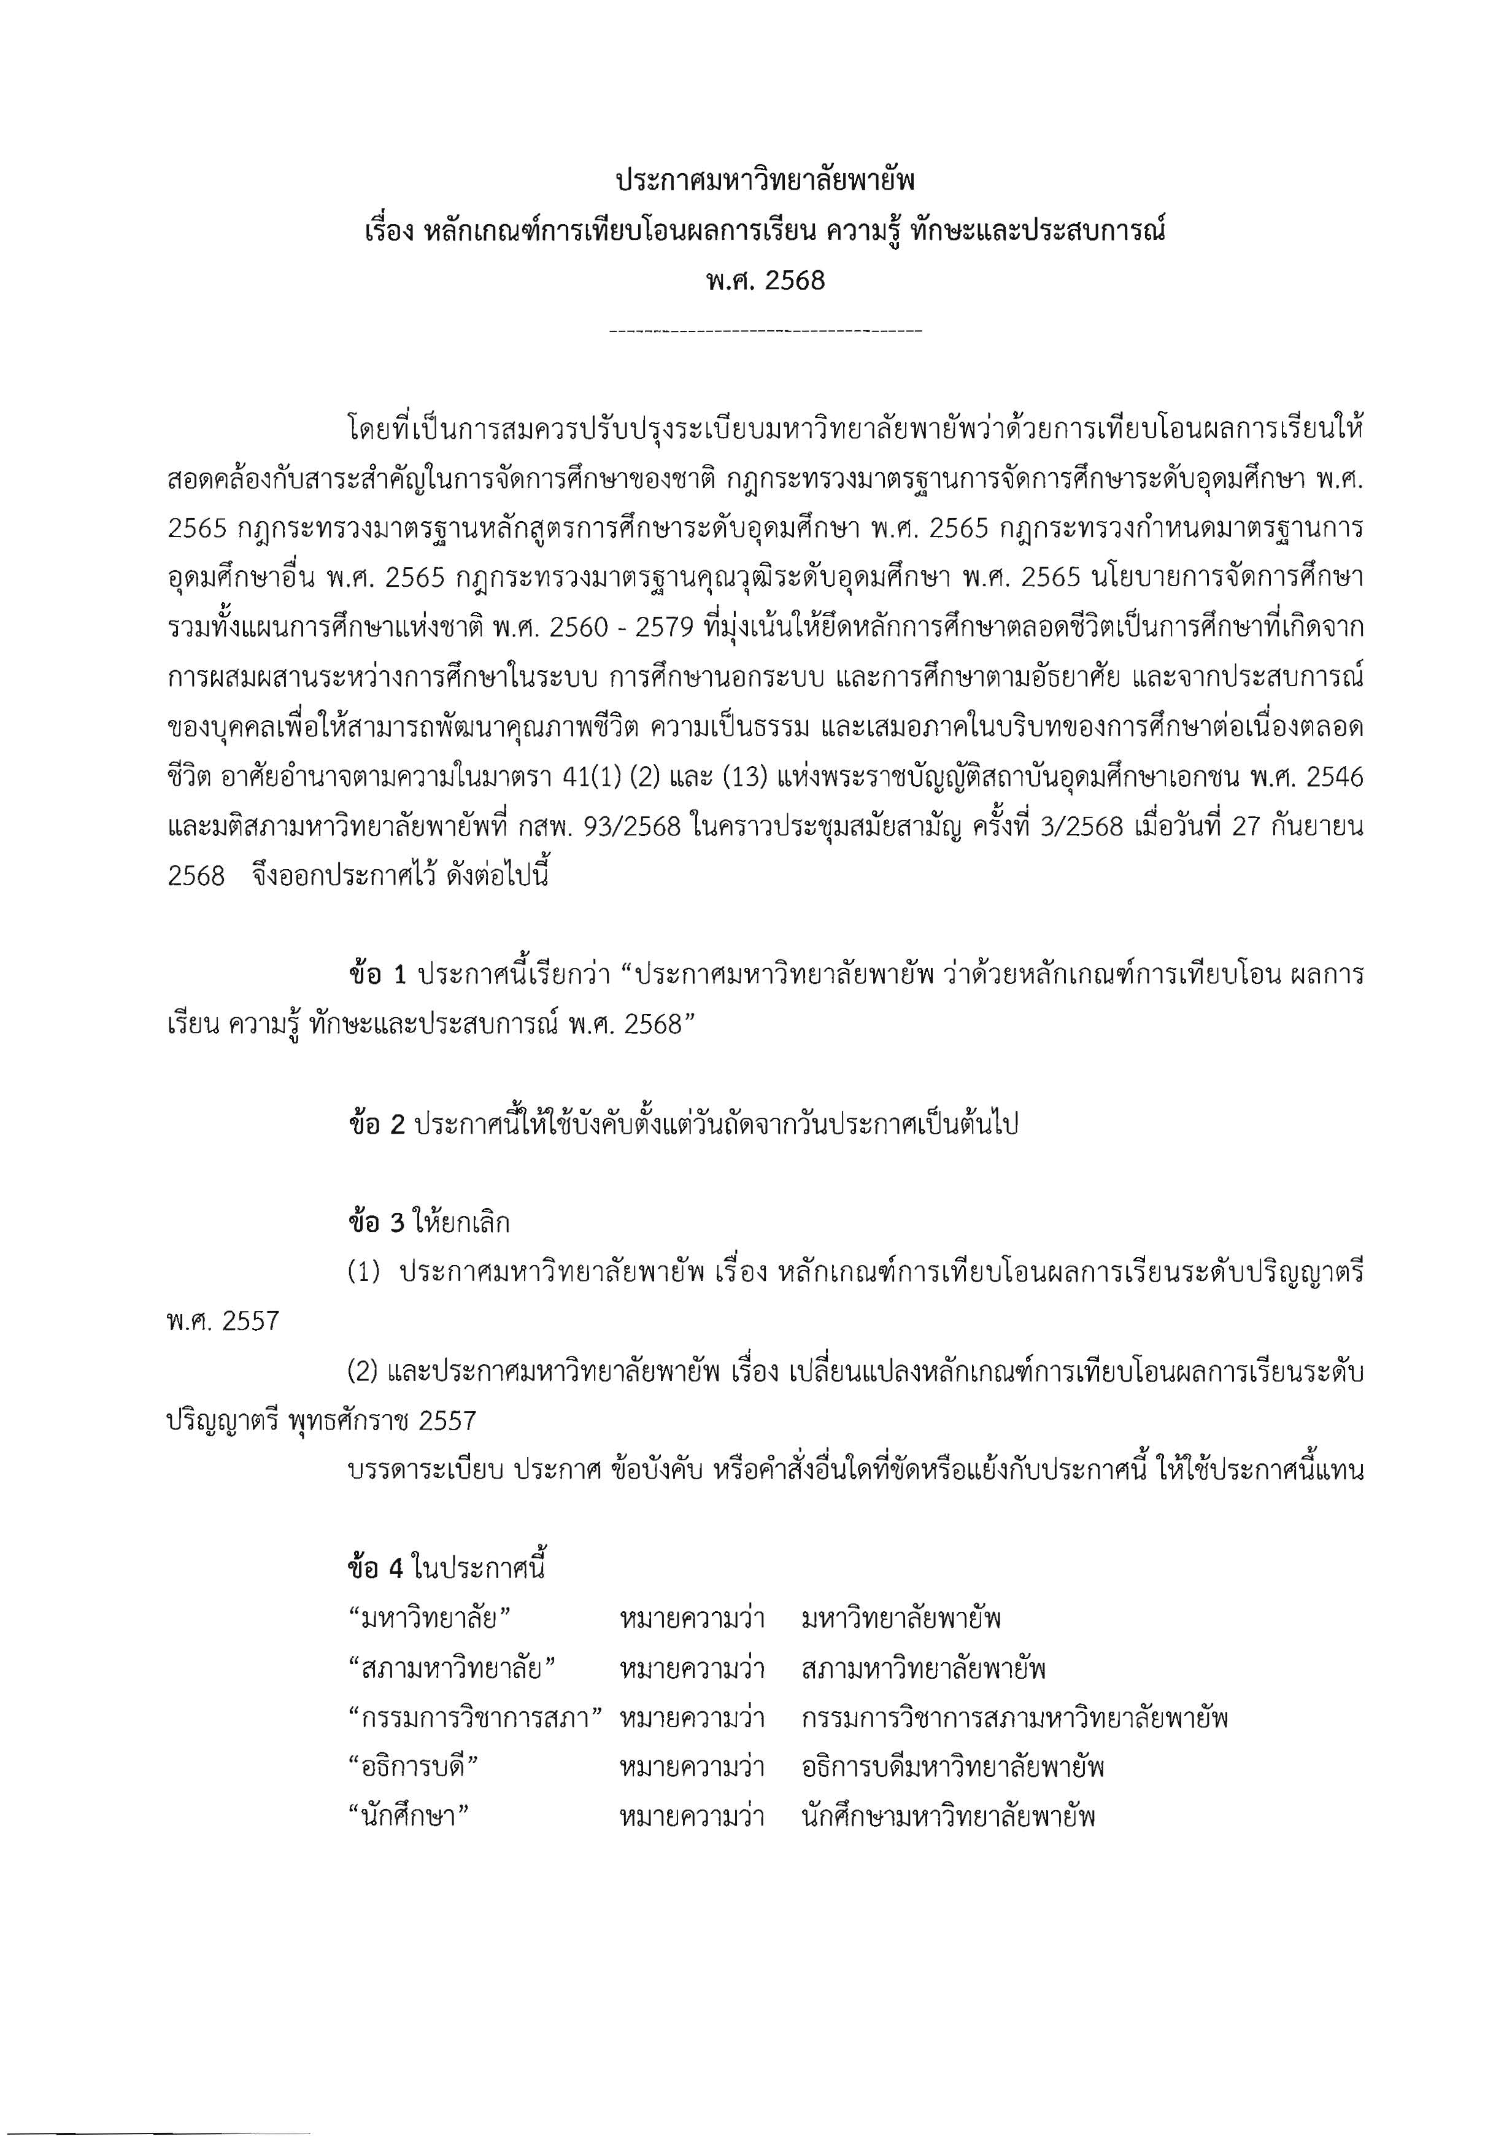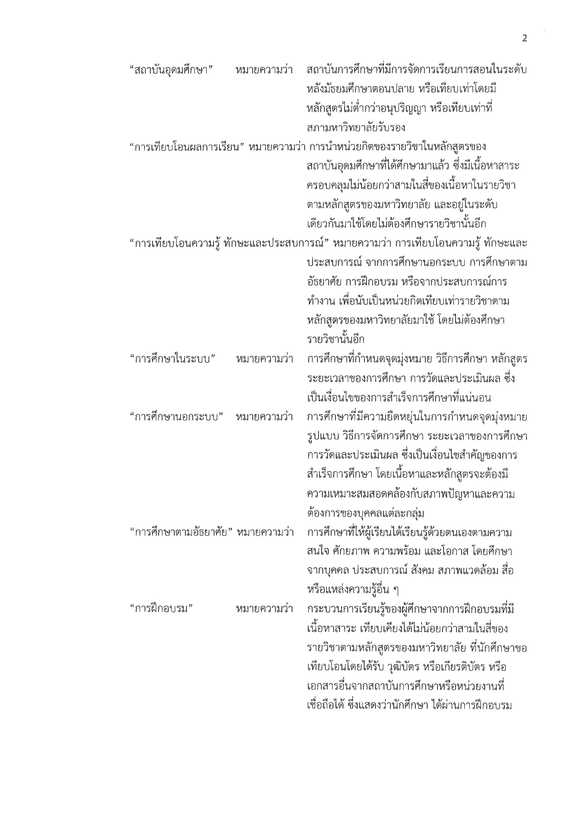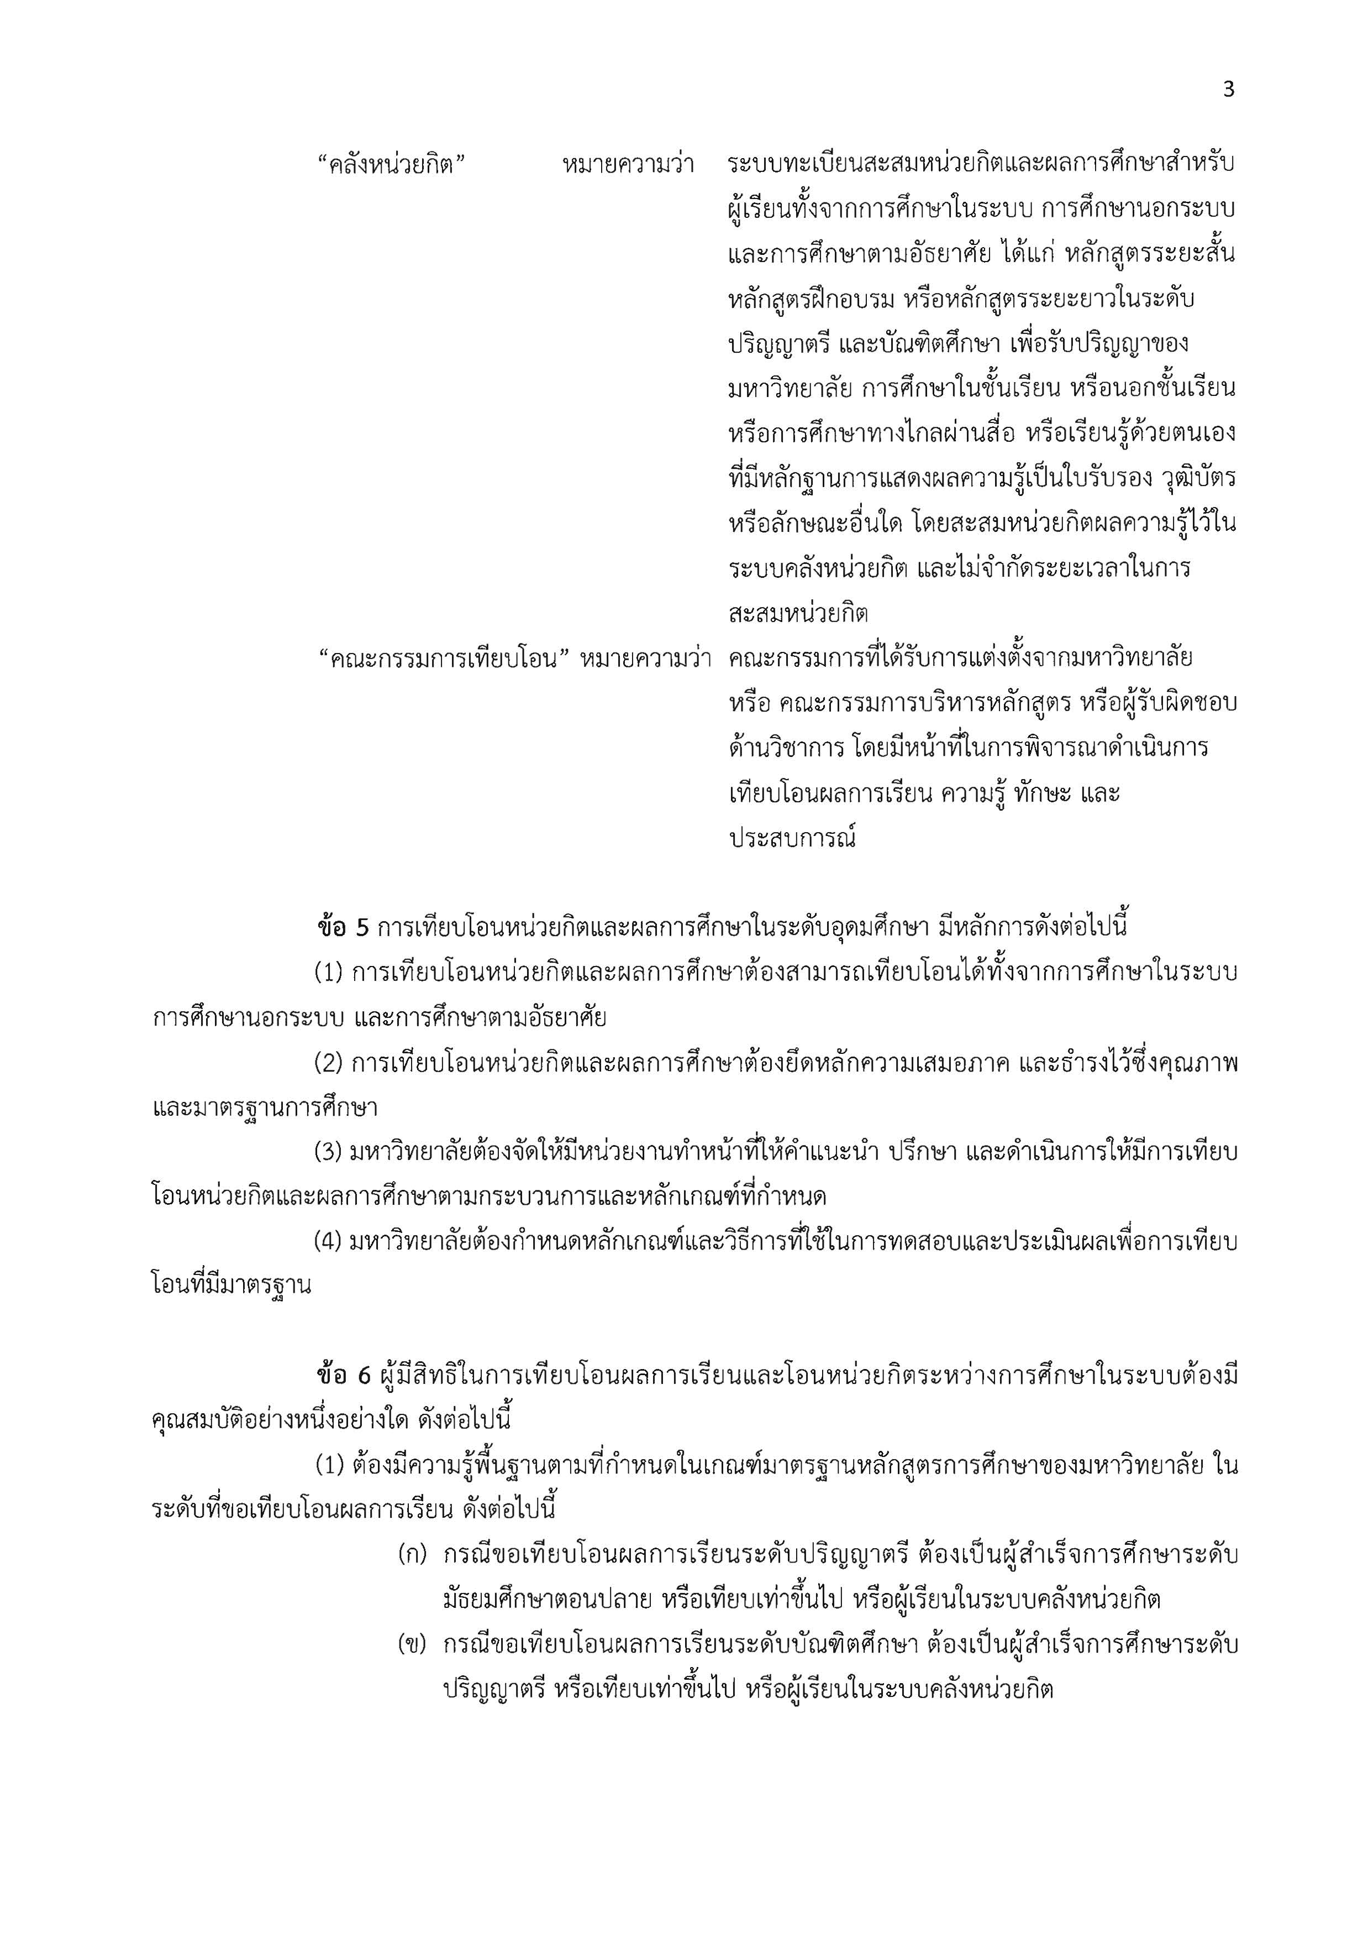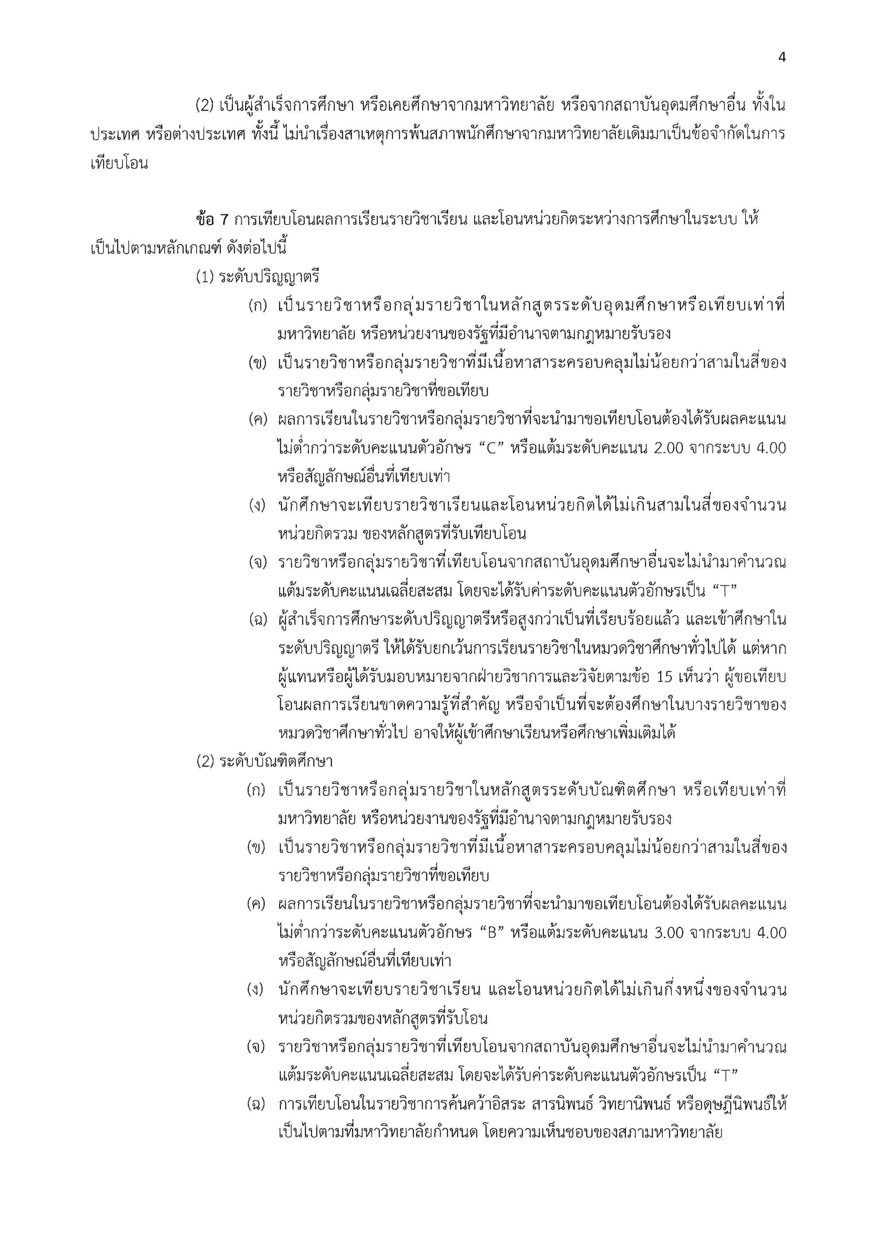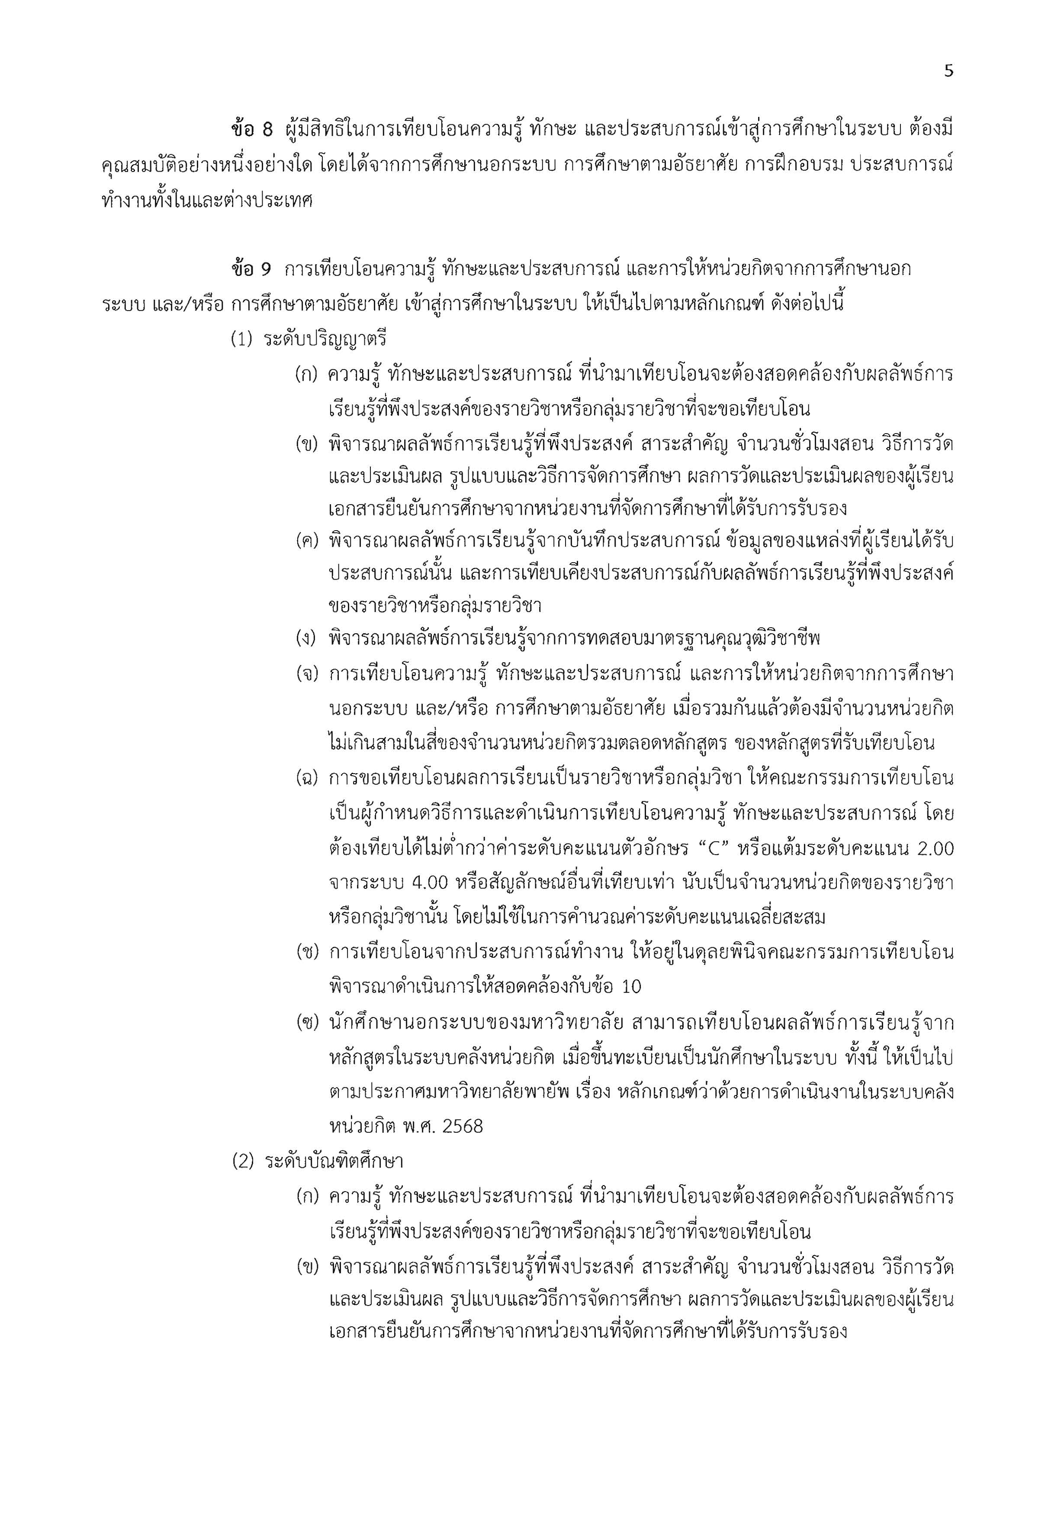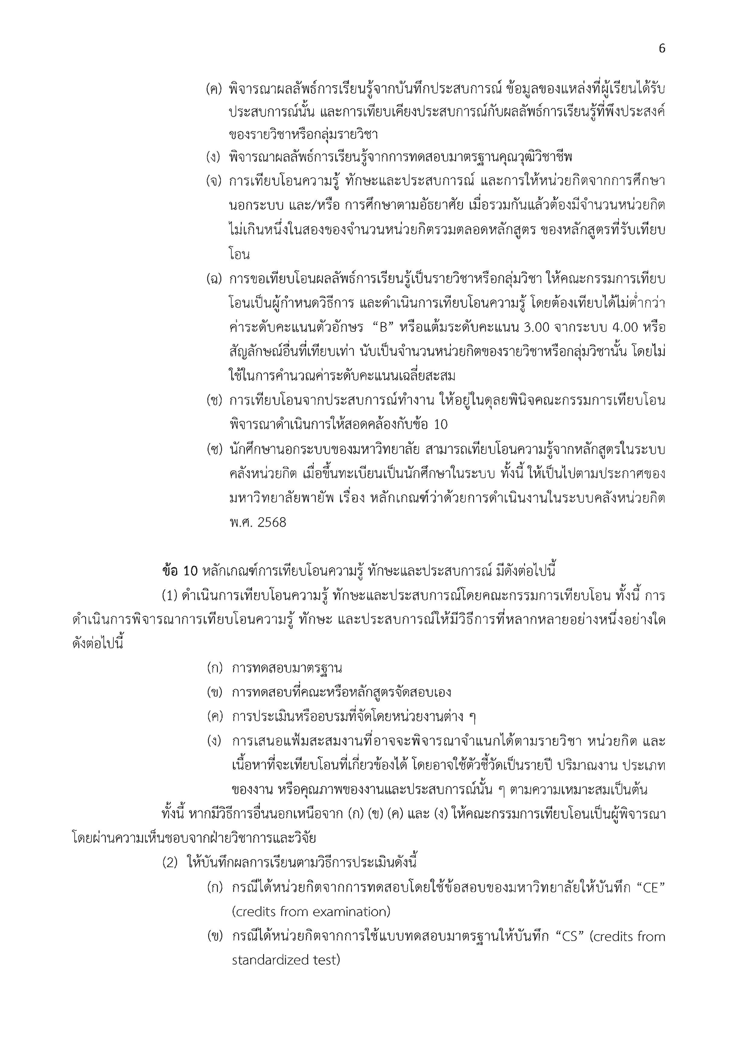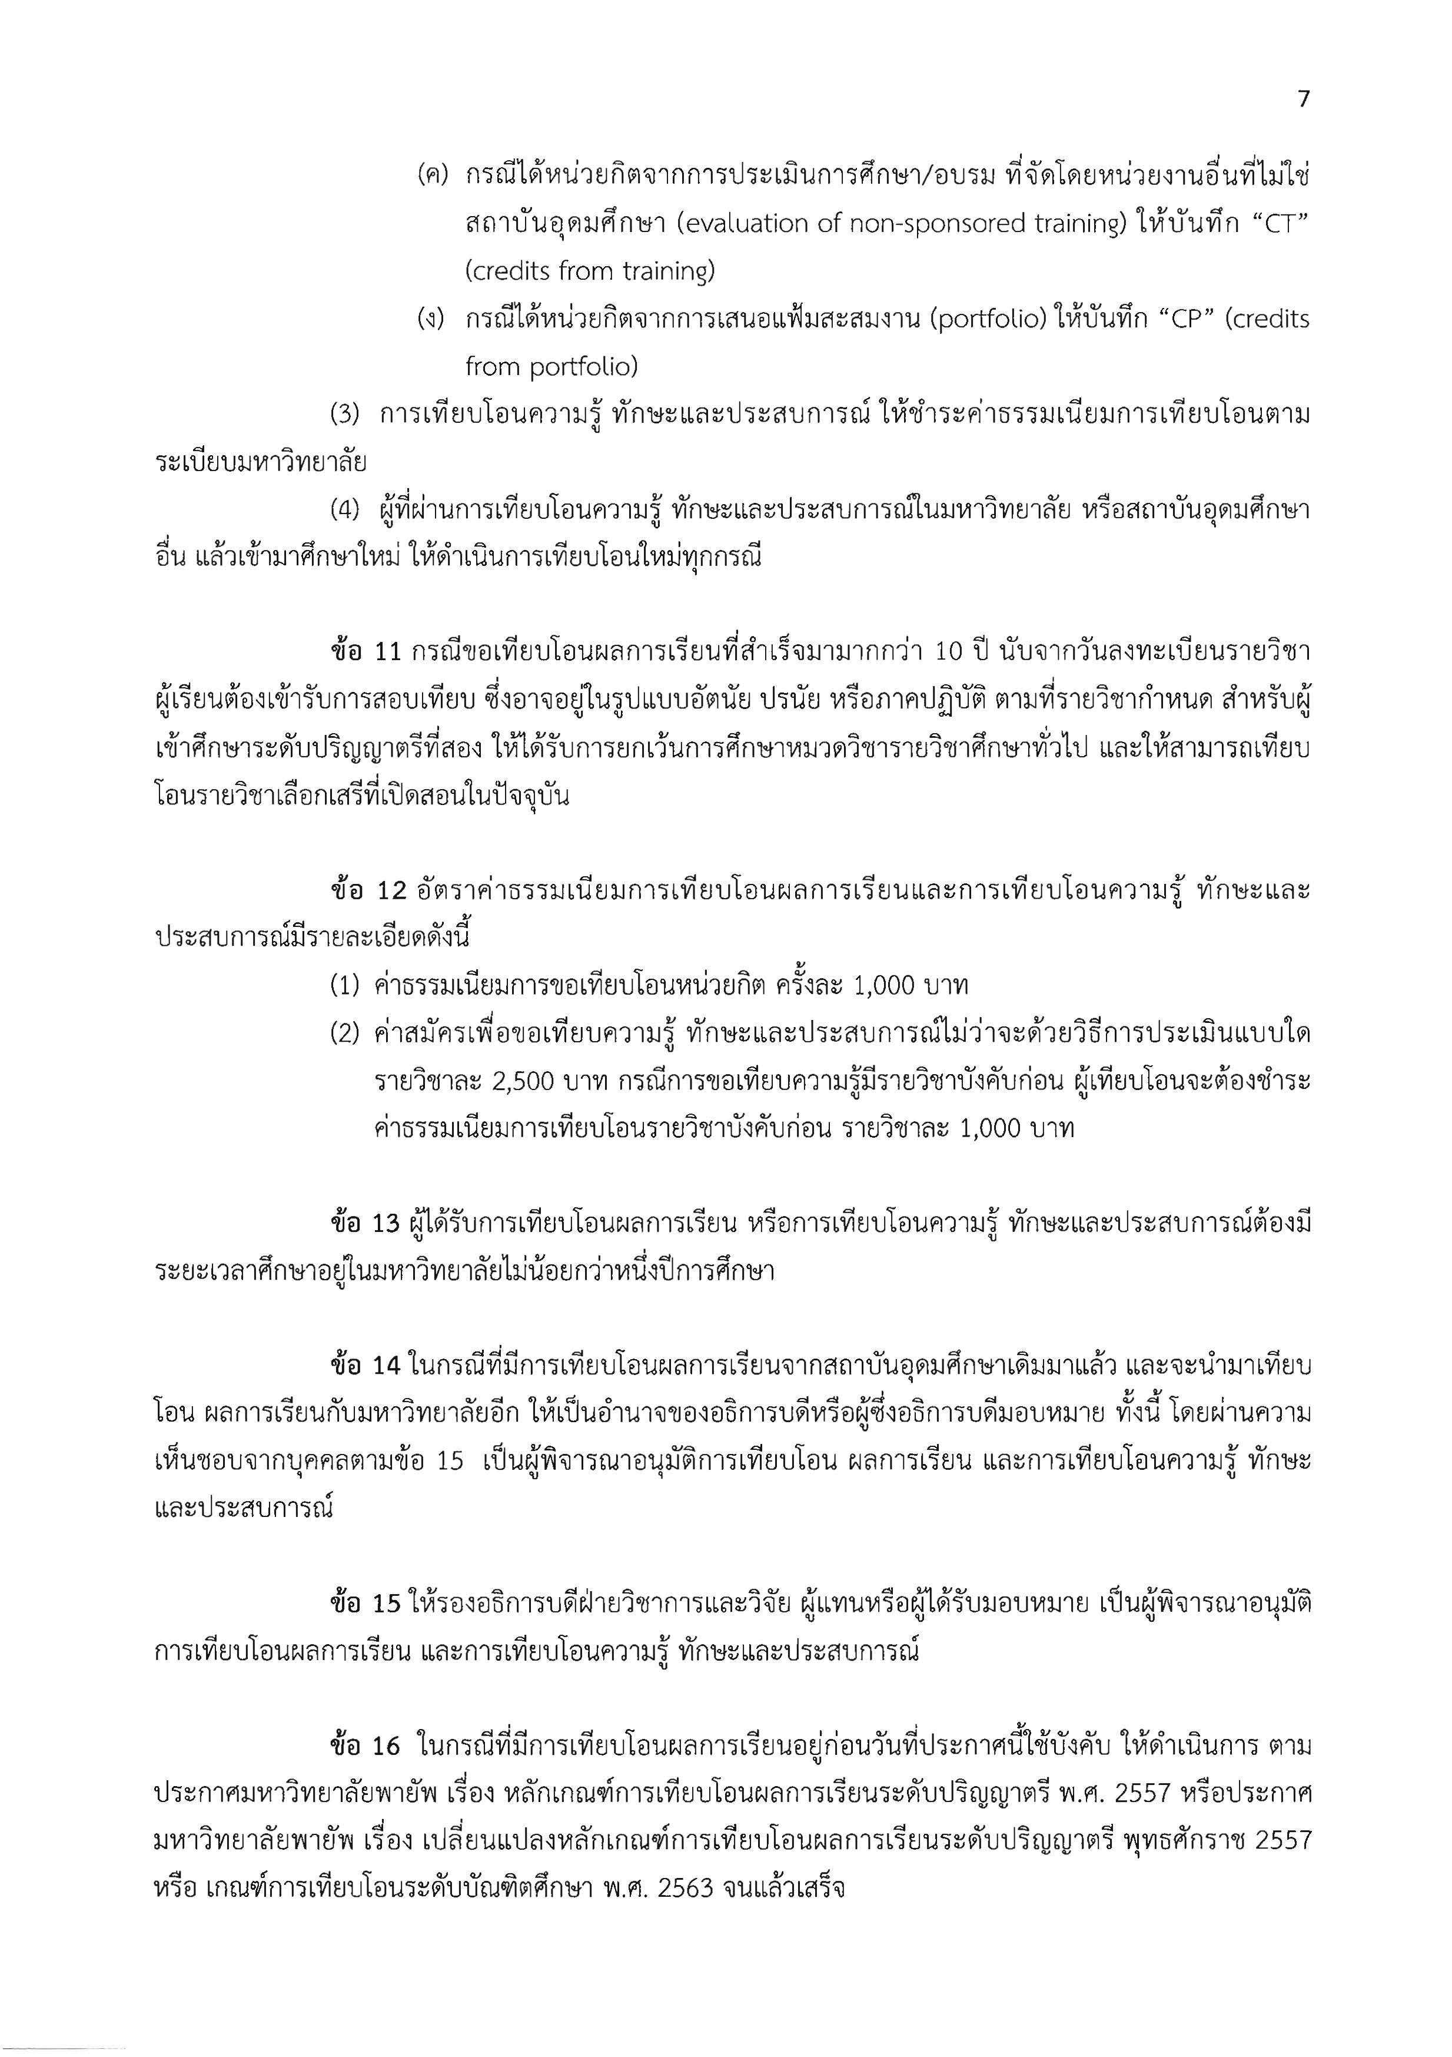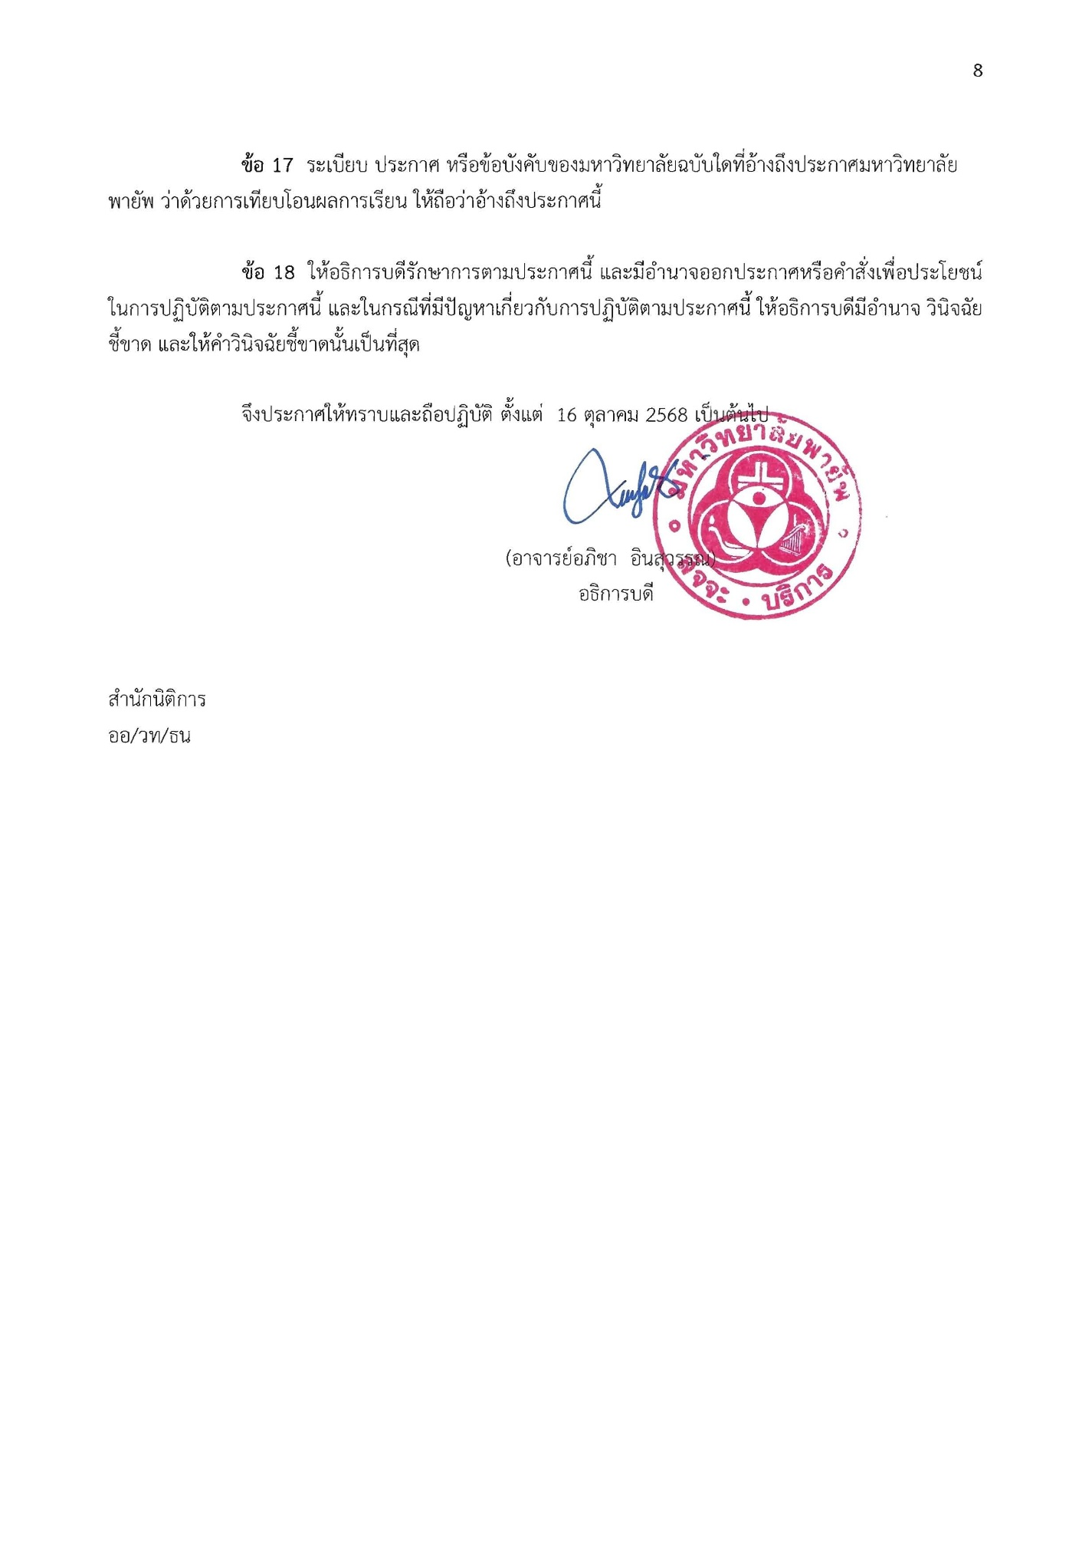

Appendix C

Course Description

Course Description

Major courses/Group of major courses (if applicable
รหัสวิชา ชื่อวิชา (บรรยาย-ปฏิบัติ-ศึกษาด้วยตนเอง)
Course code Course Name

course description

รหัสวิชา ชื่อวิชา (บรรยาย-ปฏิบัติ-ศึกษาด้วยตนเอง)
Course code Course Name

course description

รหัสวิชา ชื่อวิชา (บรรยาย-ปฏิบัติ-ศึกษาด้วยตนเอง)
Course code Course Name

course description

Appendix D

Payap University regulations about practice in the examination and postponement of the graduate studies B.E. 2550

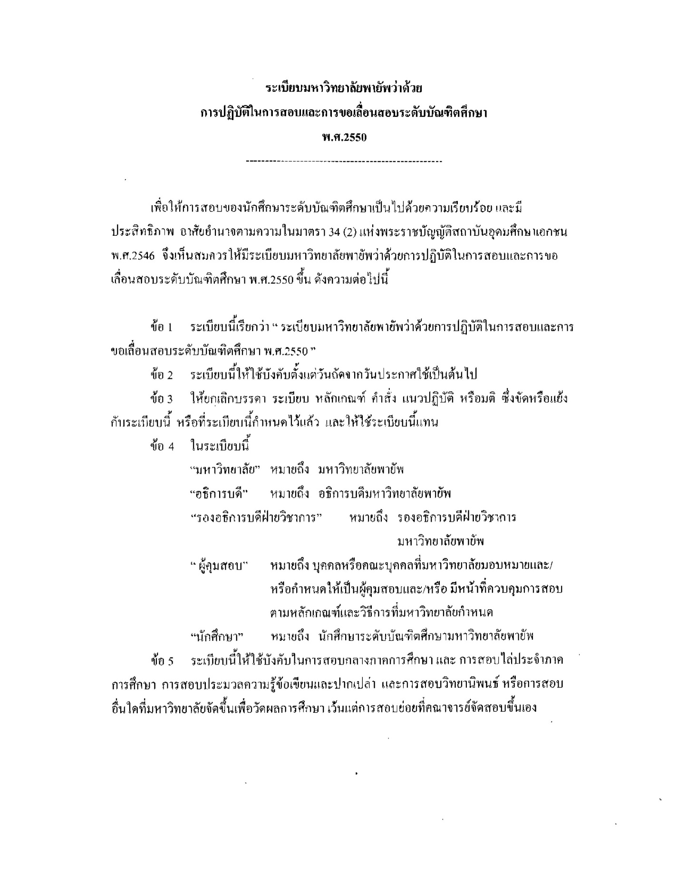
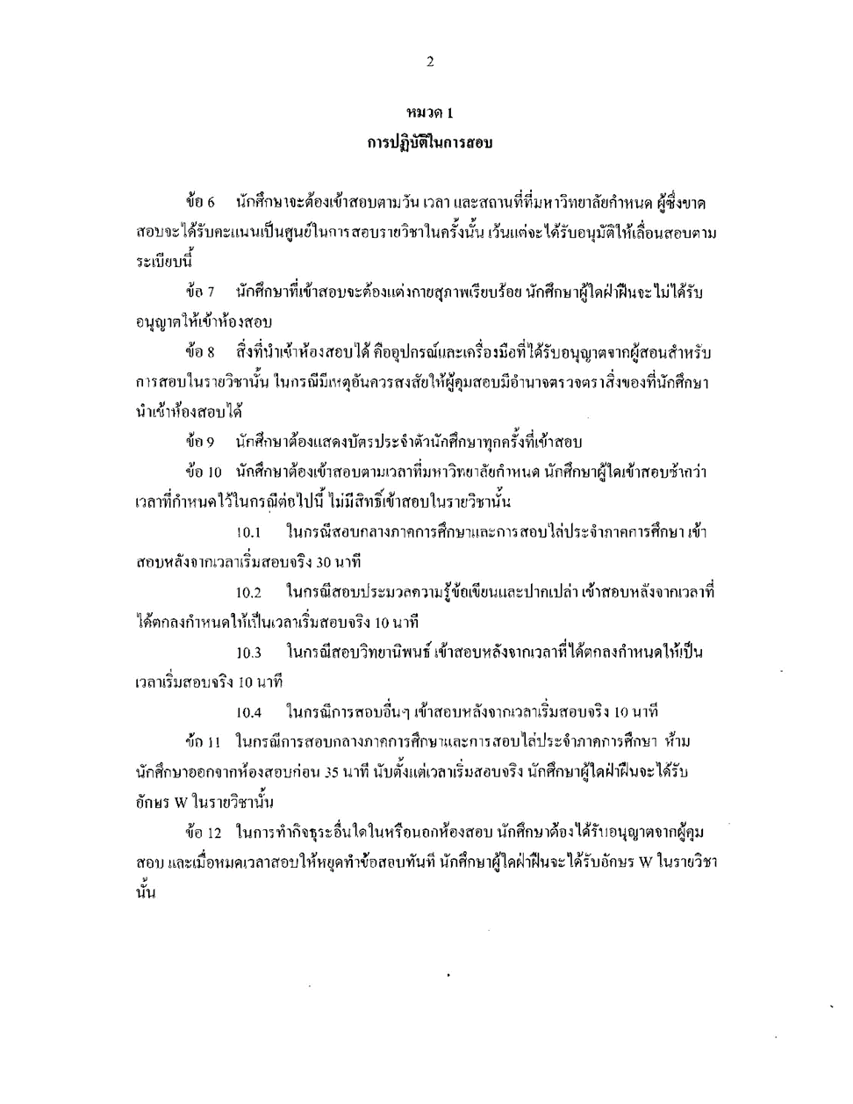

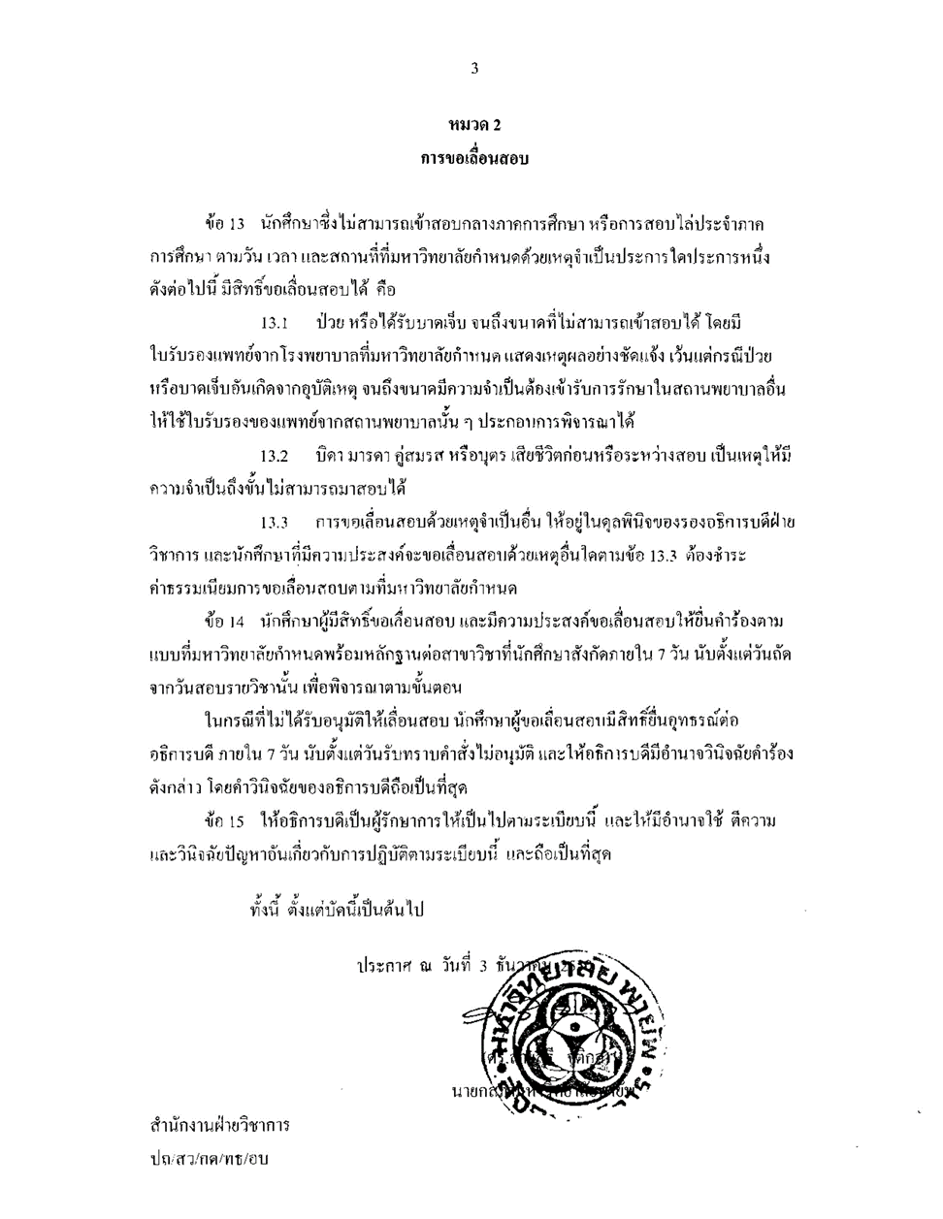

Appendix E

Payap University regulations about Exam Cheating and Plagiarism Graduate Studies B.E. 2550 and Amendments

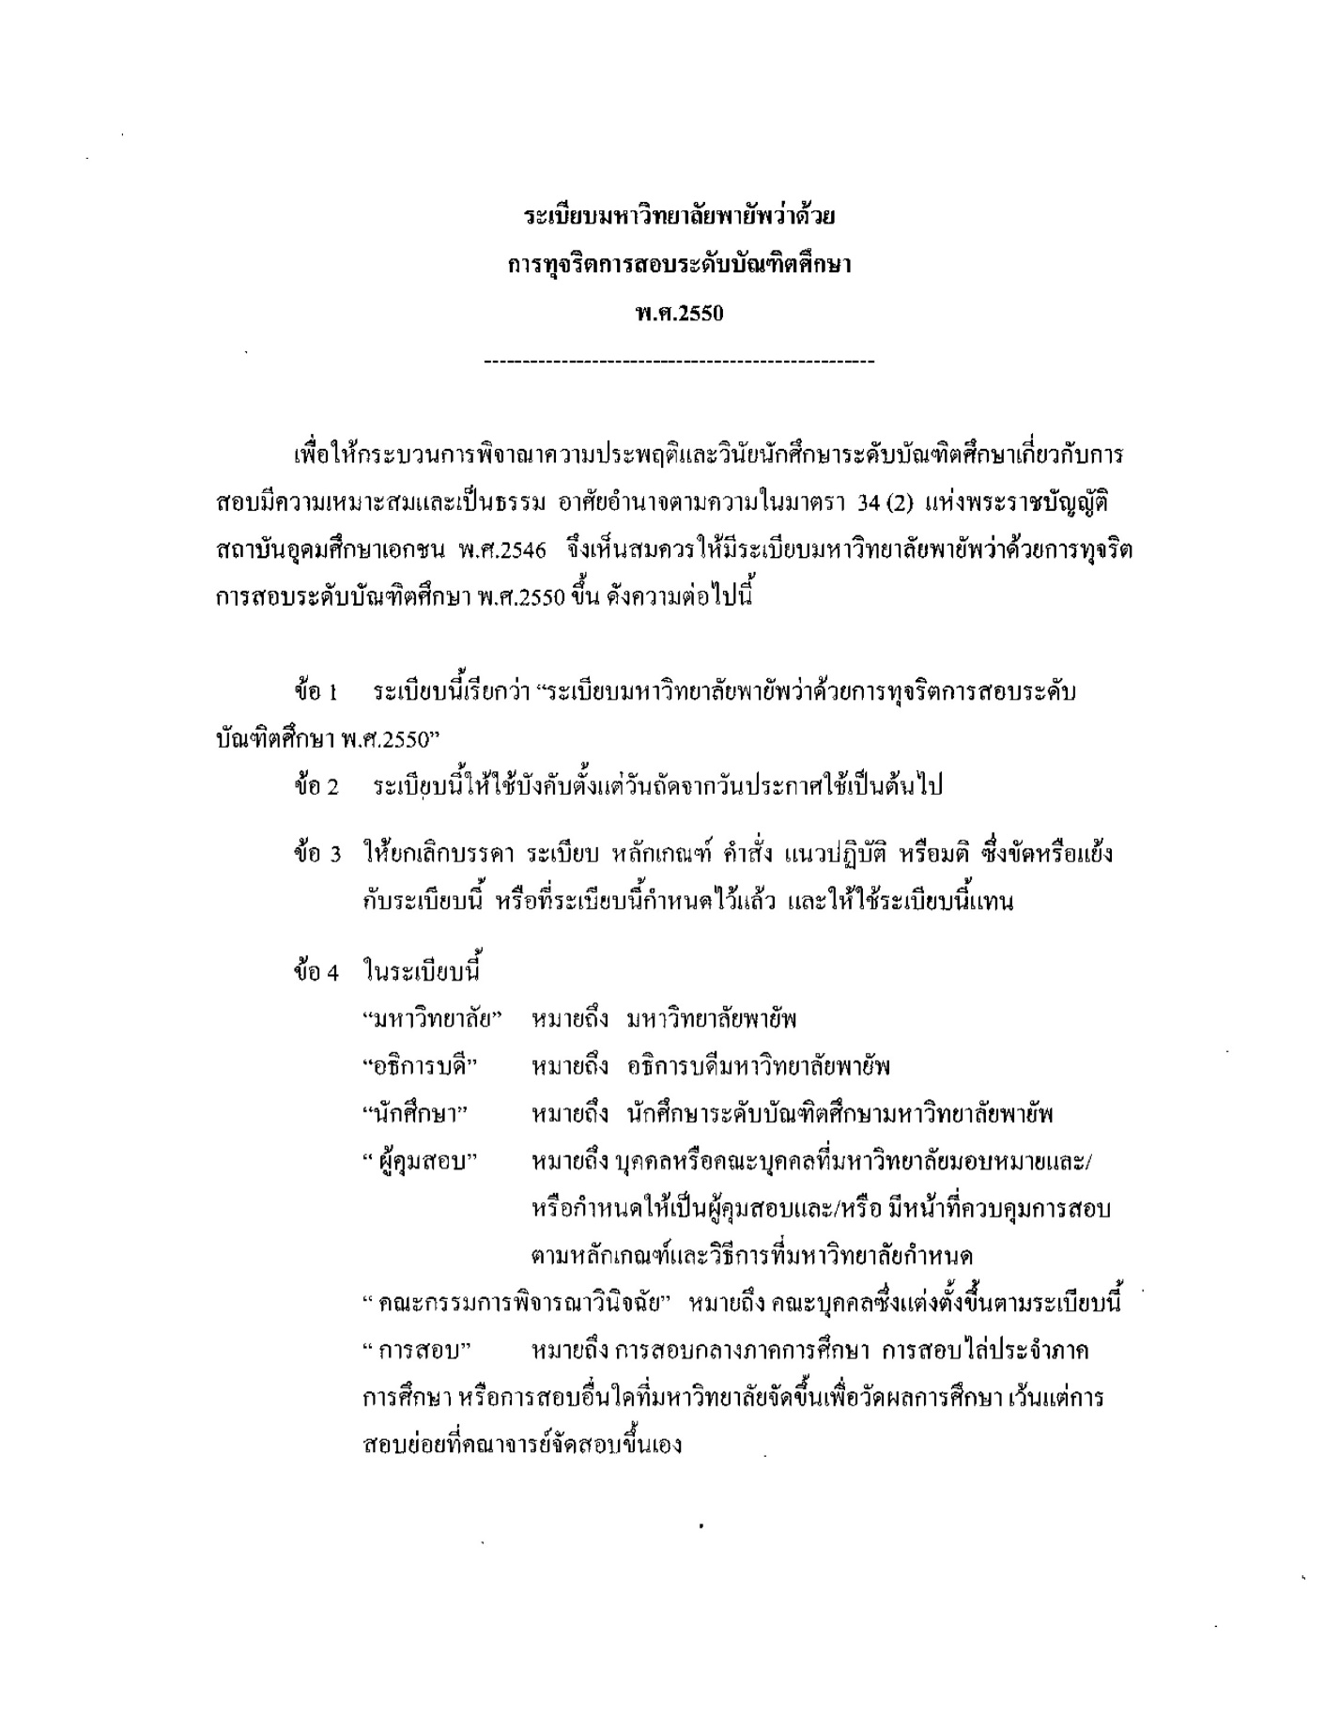

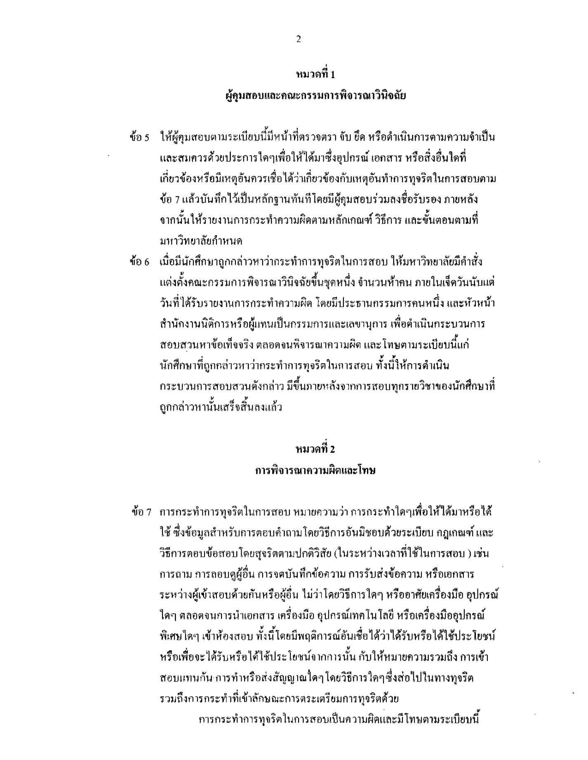

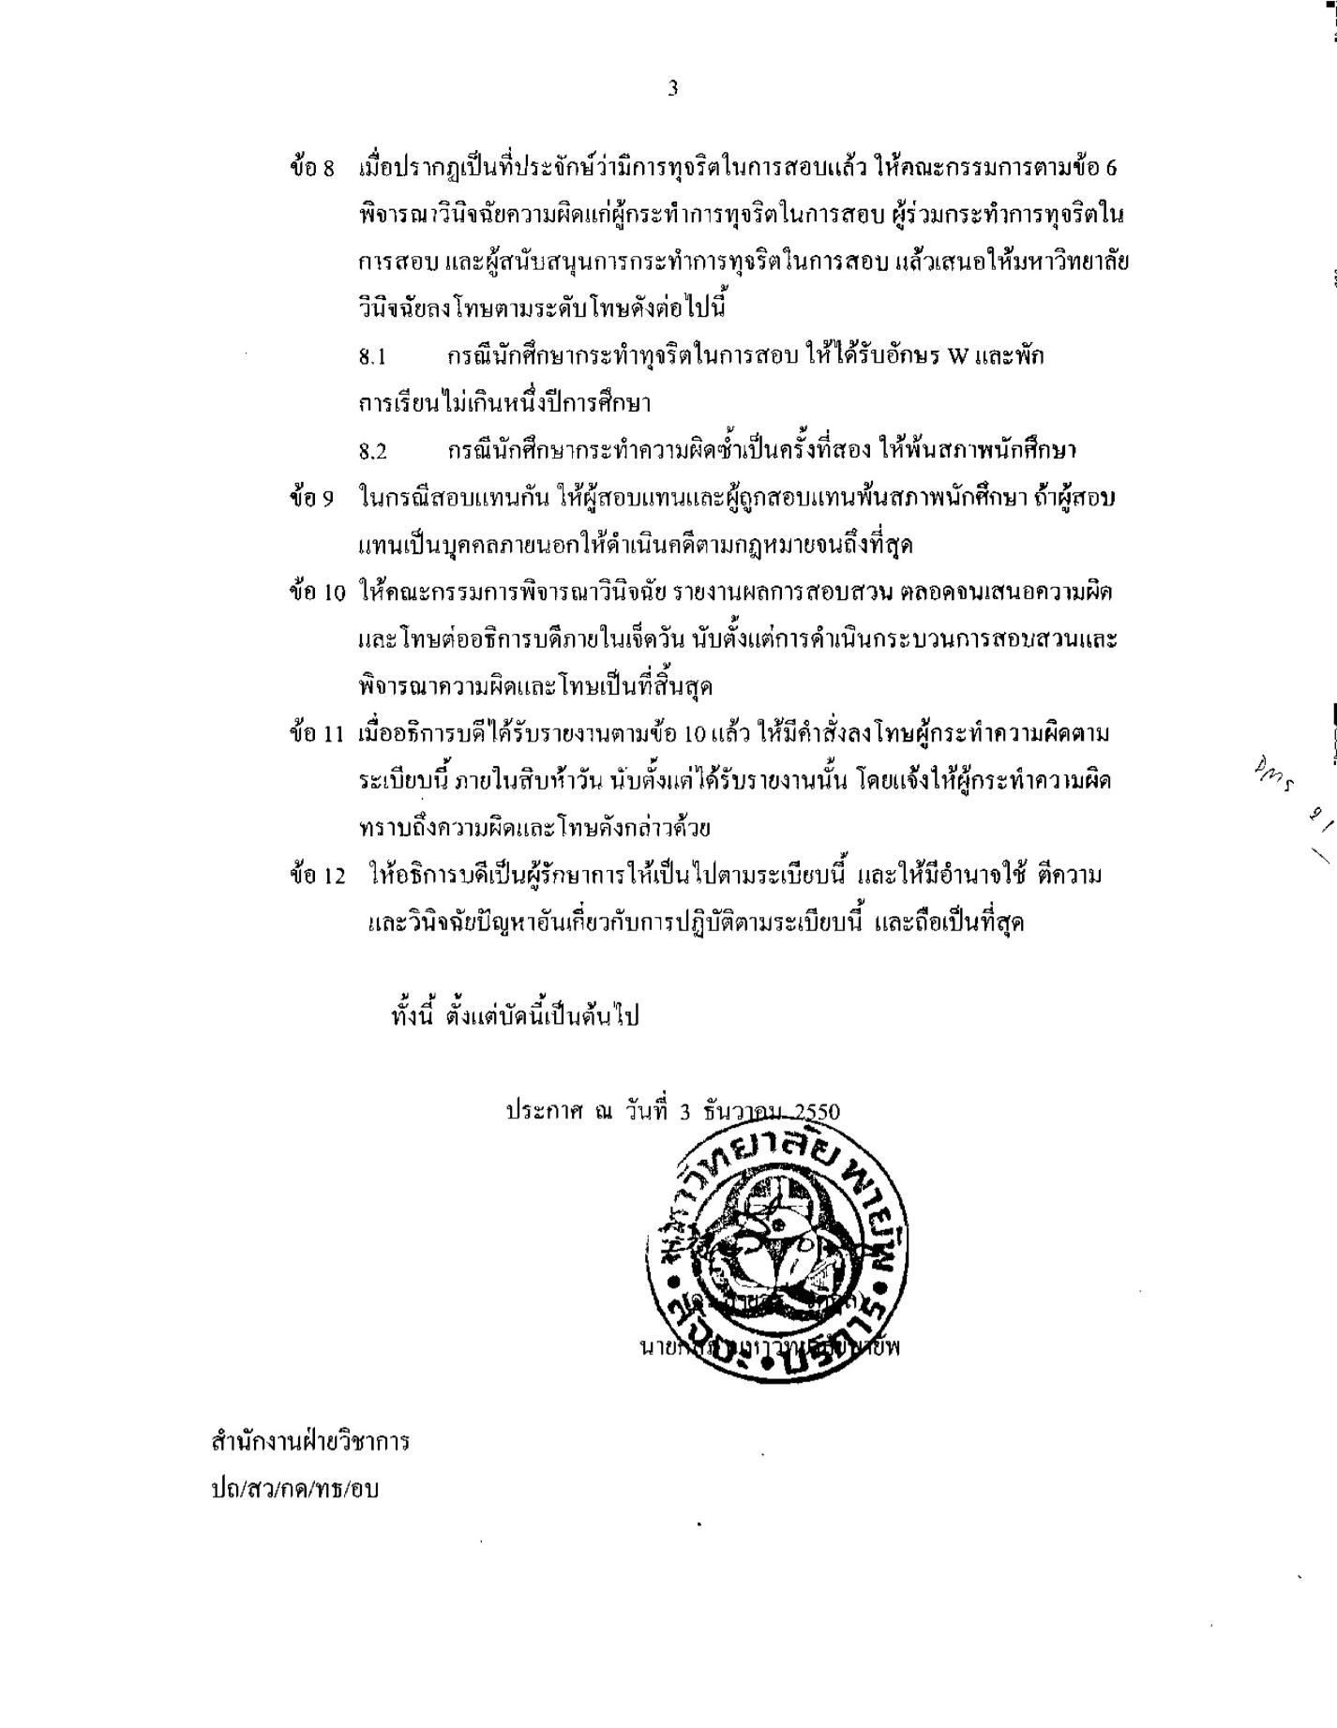

Appendix F

Database list, the list of books, journals, newspapers and audiovisual materials in the university library

Database list, the list of books, journals, newspapers and audiovisual materials in the university library

  - List of databases, books, journals, newspapers, and audiovisual materials available in the PAYAP University library.
Information Resources Statistics
Library | Current Book (Volumes) |  | Journal  (Volumes) |  | Bound Journals (Volumes) |  | Newspaper  (Titles) |  | Number of Audiovisual Materials  (Reels, Discs, Cassettes)
Library | Thai Title | English Title | Thai Title | English Title | Thai Title | English Title | Thai Title | English Title | Video | Cd-rom | Classet Tape
Total
ข้อมูล ณ เดือน พ.ศ.

  - Electronic Databases are available at Payap University library
ลำดับที่ | ชื่อฐานข้อมูล | ขอบเขตของเนื้อหา

Appendix G

Order of Payap University No...../..... Subject: Appointment of the Curriculum Development Committee .................... Department……

Appendix H

Minutes of the Curriculum Development Committee Meeting .................... Department…….

Appendix I

Copies of working contracts of non-Thai instructors who are responsible for the program

Appendix J

English Language proficiency for international graduate programs at Payap University B.E.2564

